;xefuL
Afflif{s k|ult k|ltj]bg

cf= j= @)&*÷)&(

k|sfzsM
s]GbLo sfof{no
/=g=kf= ( lrtjg
kmf]g g+= )%^–^!#%#
O{d]n: sahavagico@sahavagi.org.np
j]e ;fO{6M www.sahavagi.org.np

sfo{s

ljifo;"rL
ljifo;"rL -k]h g+= cg';f/_
! | ;+:yfut emns | #
@ | kl/ro | $
# | sfo{d"ns sfo{qmdx? | ^
#+=! | :yfgLo cfTdlge{/ sfo{qmd x'Dnf | ^
#=@ | PrcfOeL= /f]syfd, x]/rfx, ;xof]u / pkrf/ sfo{s|d, lrtjg, gjnk/f;L k'j{ tyf gjnk/f;L klZrd | *
#=# | :yfgLo emf]n'Ë] k'n lgdf{0f sfo{qmd lrtjg | !)
#=$ | s[lif cg';Gwfg kl/ofhgf | !@
$ | cWoog cg';GwfgfTds sfo{qmd | !@
^ | k|sfzgx? | !@
& | cf=a= @)&&÷)&* sf] :jLs[t sfo{qmd tyf jh]6 tyf n]vfkl/If0f k|ltj]bg | !#
* | cf=j= @)&*÷)&( sf] k|Ztfljt sfo{qmd tyf jh]6 | !#
( | cf=j= @)&&÷)&* df ;~rflnt sfo{qmdx? | !#
!) | ;+:yfsf] ;+u7gfTds 9f+rf | !$

!= ;+:yfut emns

sfg'gL cl:tTj
:yfkgfM lj=;= @)%# - O{=;= !((&_
btf{M lh=k|=sf=, lrtjg
btf{ g+ M !)# . )%# . )%$
btf{ ldltM @)%# . !@ . @%
;=s=k=cfM @)%^ . $ . !$

cflwsf/Ls ;+/rgf
;fwf/0f ;efM k|To]s jif{ clgjfo{ ?kdf
sfo{;ldltM ( ;b:ox?
-# dlxnf, $ k'?if, ! blnt, ! hghflt_
;fwf/0f ;b:oM @& hgf

dfga ;fwg
hDdf sd{rf/L M @* -k'?if– * ,dlxnf–@)_
s]lGb|o sfof{noM &
zfvf sfof{nox?dfM @!

sfo{cjlw
jflif{s ;fwf/0f ;efM k|To]s jif{
sfo{;ldltsf] sfo{sfnM tLg jif{
sfo{;ldlt a}7sM k|To]s tLg tLg dlxgfdf

jt{dfgdf ;xsfo{ ul/Psf ;fem]bf/ ;+:yfx?
USAID/EpiC kl/of]hgf
s[lif cg';Gwfg kl/of]hgf
:yfgLo emf]n'Ë] k'n sfo{s|d
lrtjgsf ;a} kflnsfx? -ufpmkflnsf tyf gu/kflnsfx?_
ljutdf ;xsfo{ ul/Psf ;fem]bf/ ;+:yfx?
kmf:6]gf]km/
x]Ne]6f; g]kfn
USAID/EpiC
;fy ;fy kl/of]hf÷Pkm=Pr=cfO=#^) g]kfn
PlzofnL ljsf; a}+s÷ci6«]lnog g];gn=o'lgel;{6L
lh=;=;= lrtjg
e/tk'/ c:ktfn
cS;kmfd lh=lj=
o'=P;=P=cfO{=l8=
o'= Pg= j'dg
lrtjgsf ;a} kflnsfx? -ufpmkflnsf tyf gu/kflnsfx?_

@= kl/ro

@= ! ;+:yfut kl/ro
æ;xefuLÆ :jfjnDjg / ;xeflutfTds ljsf; k4ltdf ljZjf; /fVg] / o;} k4ltdf nfdf] sfo{ut cg'ej ePsf Joj;flos lj1x?åf/f :yflkt Pp6f ;fdflhs ;+:yf xf] . of] ;+:yf lhNnf k|zf;g sfof{no lrtjgdf @)%# ;fn r}q @% ut] -;g=!((&_ ;fdflhs ;+3÷;+:yf btf{ P]g, @)#$ cGtu{t btf{ ePsf] 5 . o;}u/L ;dfh sNof0f kl/ifb\ -*(&!_, cfGTfl/s /fh:j sfof{no -kfg g+ M #))##$$##)_, Uf}=;=;= lrtjg -#)%–@)%*÷%(_, u}=;=;= dxf;+3 (C.R.CHI-27), k|hftflGqs u}=;=;= dxf;+3 g]kfn (FEDEN), P8\; lj?4 /fli6«o g]6js{ ;d"x g]kfn (NANGAN) / g];f] lrtjg -!_ df btf{ tyf cfj4 e};s]sf] 5 .
of] ;+:Yff ;xeflutf / ;fem]bf/Ldf ljZjf; ub{5 . ;xeflutfTds ljsf;sf] nflu ;/sf/L, ;fdflhs, gLlh, /fli6«o, cGt/fli6«o, ax'/fli6«o ;+3 ;+:yf / ;d'bfosf dflg;x?;+u ldn]/ ;fem]bf/Ldf sfd ug]{ OR5f /fVb5 . o;n] cfkm\gf] cg'ejnfO{ o:t} If]qdf sfd ug]{ cGo ;+3 ;:yfx?;Fu cfbg k|bfg ug{ rfxG5 .

cfly{s, ;fdflhs tyf /fhg}lts ?kn] ljkGg ju{sf] ?kdf /x]sf dlxnf, l;dfGt kl/jf/, blnt tyf hg hfltx?sf] cfTd ljsf;sf] nfuL pgLx?nfO{ g} ;zQm agfO{ ljsf;sf] d"nwf/df ;xefuL x'g] jftfj/0fsf] ;[hgf ug'{ jt{dfg ;dosf] cfjZostf xf] . k|To]s dflg;df cGt/lglxt Ifdtf / zlQmnfO{ l7s tl/sfn] klxrfg u/L kl/rfng ug{ d4t k'¥ofOof] eg] dfgj dfqsf] ;jf{lË0f ljsf;df 6]jf k'Ug ;Sb5 eGg] dfGotfdf ;xefuLn] ljZjf; /fVb5 . To;}sf/0f ljsf; k|lqmofdf kl5 k/]sf cyjf g;d]l6Psf ljkGg ju{x? h:t} dlxnf, blnt ;d"bfosf dflg;x?;+u ldn]/ sfd ug{ rfxG5 . o; cltl/Qm cfkm\gf] cg'ej / bIftfnfO{ ljkGg ju{df /x]sf ;d"bfosf dflg;x?sf] kIfdf pkof]u ug{ OR5's cGo ;+3 ;+:yf, g]kfn ;/sf/ tyf cGt/f{li6«o ;+:yfx?;+u klg ;fem]bf/Lsf] ?kdf sfd ug{ rfxG5 .

lj=;= @)%# ;fndf :yfkgf ePsf] ;xefuL ;+:yfn] ljkGg ju{sf dflg;x?, ljz]if ul/ blnt, dlxnf / l;dfGts[t kl/jf/nfO{ ;xefuLtfTds ljsf; k|lqmofdf ;+nUg u/fpb} p2]Zod'ns tyf ldl>t ;d"x u7g ul/ :yfgLo ;+:Yffsf] dfWodaf6 ;dflhs / clfy{s ljsf;sf] nflu r]tgf, clej[[l4, dlxnf :Jff:Yo, ef}lts k"jf{wf/ tyf cfo cfh{gsf sfddf ;+nUg x'b} cfO/x]s]f 5 . sfo{d"ns sfo{s|dsf] cg'ejaf6 k|fKt / ;LknfO{ gLltut, cWoog, cg'zGwfg, tflnd, uf]i7L tyf k|sfzgsf] dfWodaf6 ;/f]sf/jfnf ;+3 ;:Yff / cfd ;d'bfo ;dIf k'/\ofPsf] 5 .

;+:yf :yfkgfsf] !) jif{ k'u]sf] cj;/df /0fg}lts of]hgf th'{df ul/ ;+:yfn] ljut b]lv /fv]sf] kl/sNkgf, Wo]o, nIf / p2]Zodf s]lx kl/dfh{g ;d]t u/]sf] 5 . b]zsf] kl/jlt{t /fhg}lts ;+be{, ;+l3o u0ftflGqs /fHo Joj:yfsf] zlQm ;+/rgfdf ;lhn} kx'Fr k'Ug g;Sg] / ljsfzsf] k|ltkmn kfpg af6 6f9} /x]sf ljkGg Pj+ jl~rt ju{sf] ;jf{ËL0f ljsf;sf] nfuL ;xeflutfTds k¢lt åf/f ;zlQms/0fdf of]ubfg k'/\ofpg' kg]{ cfjZostfnfO{ kl/dfh{g ul/Psf VMGO n] cfTd;fy u/]sf] 5 . ;+:yfn] xfn cjnDjg u/]sf] kl/sNkgf, Wo]o, nIo / p2]Zo lgDg cg';f/ 5g\ .

s_ kl/sNkgf
;fdflhs ?kdf ;f}xfb{ / cfly{s ?kn] cfTdlge{/ ;dfhsf] lgdf{0f .
v_ Wo]o
zlQm ;+/rgfdf kx'Fr gePsf / ljsfzsf] k|ltkmn kfpg af6 6f9} /x]sf ljkGg Pj+ jl~Rft ju{sf] ;xeflutfTds k¢ltåf/f ;zlQms/0fdf of]ubfg k'¥ofpg] .
u_ nIo
zlQm ;+/rgfdf kx'Fr gePsf, ljkGg, u/Lj, blnt, kLl8t tyf dlxnfx?nfO{ ;xefuLtfTds k|lqmofdf ;+nUg u/fO{ ;d'Ggt ;dfhsf] lgdf{0f ug'{ .
3_ p2]Zo
- ul/j, l;dfGt kl/jf/, blnt, kLl8t ju{ / dlxnfx?nfO{ ;xefuLtfd'ns ljsfz k|ls|ofdf ;+nUg u/fO{ plgx?sf] ;fdflhs tyf cfly{s :t/ psf:g] .
- ul/j / dlxnfx?;Fu sfd ug]{ ljwL / k|ls|of ;d]l6Psf gd'gf nfos sfo{s|dx?sf] ljsfz ug]{ .
- b]z ljsfzdf ul/j, ;LdfGt kl/jf/, blnt, kLl8t ju{ / dlxnfx?sf] ;zlQms/0fsf] nflu cg';GwgfTds sfo{ tyf cu'jfO{ ug]{ .

@=@ sfo{ gLlt
- nlIft ;d"bfosf dflg;x?df ;fd"lxs efjgf tyf :jfjnDag ljsf;sf] nfuL r]tgf clea[l4 tyf ;+:yfut ljsf;sf sfo{qmd ;+rfng ug]{ .
- ufp+m, lhNnf tyf /fli6«o :t/df tflnd, sfo{zfnf uf]i7L, cGt/lqmof / ;]ldgf/x?sf] cfof]hgf u/L ;xeflutfTds sfo{ k|0ffnLsf cg'ejx? cfbfg k|bfg ug]{ .
- n}lËs ,hft hflt tyf ul/jd"lv gLlt tyf sfo{qmdsf nfuL cu'jfO{ tyf ;Nnfx k|bfg ug]{ .
- :yfgLo :t/df cfjZostf cg';f/ ;xeflutfTds cfod"ns tyf l;k ljsf;sf tflnd cof]hgf ug]{ .

@=# lgb]{zs l;4fGtx?
- æ;]jsn] ;'v / duGt]n] dfg gvf]Hg' t/ :jfledfg gu'dfpg'Æ
- ælgbfPsfnfO{ ljpemfpg ;lsG5 t/ lgbfPsf] jxfgf ug]{nfO{ sl7g kl/>d ug'{kb{5Æ
- æsfo{stf{ Pp6f gd"gf kfq xf], hf] g}lts?kn] rl/qjfg x'G5, ;/n hLjg ofkg ub{5 / sfddf st{Jolgi7 x'G5Æ

@=$ cfrf/–;+lxtf
;+:yfdf sfo{/t sfo{stf{÷ sd{rf/L n] kfngf ug'{kg]{ g}lts lgod tyf ;'/Iffsf sfo{x?
!=lgb]{zs l;4fGtx?sf] k"0f{?kdf kfngf ug]{ .
@=;fj{hlgs :yfg, sfo{qmd jf sfo{fnodf s'g} klg /fhgLlts ljifodf 5nkmn, ax; jf 6Lsf6LKk0fL gug]{ .
#=sfo{qmdsf] nIo, p2]Zo / k|lqmof af/] s;}n] hfgsf/L dfu]df lzi6 / ;Eo efiffdf ;a} s'/f kf/bzL{ lsl;dn] a'emfO{ lbg] .
$=;+:yfsf ;+rfns ;ldltsf kbflwsf/L af/] ;f]wvf]h / hfgsf/L dfu]df yfxf ePsf] s'/fdfq :ki6 egL lbg] .
%=åGåsf] ;dodfdf åGådf ;+nUg kIf÷ljkIfsf s'/f j;f/ k;f/df gnfUg] .
^=bft[ ;+3 ;+:yfsf ;DaGwdf cfjZos / cfkm"nfO{ yfxf ePsf] eGbf a9L s'/f gjf]Ng] .
&=lkmN8df e|d0f ubf{ ;'/Iffsf] l:ylt a'em]/ dfq ug]{ .
*=;Defljt b'3{6gfnfO{ Wofgdf /fvL ;a} sd{rf/Lx?sf] b'3{6gf ljdf of]hgfnfO{ lg/gt/tf lbg]
(=sfo{ If]qdf s'g} ck|Toflzt 36gf 36\g uPdf s]Gb|Lo sfof{no jf ;DalGwt kbflwsf/LnfO{ t'?Gt ;"rgf ug]{ .
!)=;fdflhs ;+:yf dfxf;+3-NGO Federation Nepal_ 4f/f tof/ ul/Psf] cfrf/ ;+lxtf tyf g]kfndf sfo{/t cGt/fli6«o lgsfoåf/f k|sflzt lgb]{zs l;4fGt ;d]tnfO{ cfbf/ / ;Ddfg ug]{ .

@=% Joj:yfkg tyf ;+rfng
“;xefuL” sf] Joj:yfkg / ;~rfngsf nflu ( hgfsf] sfo{ ;ldlt 5 . hf] k|To]s # jif{sf] nflu ;fwf/0f ;efaf6 lgjf{lrt x'G5 . jif{df ;fdfGotof $ k6s sfo{ ;ldltsf] j}7s a:b5 . ;+:yfsf] hgzlQm Joj:yfkg / kl/of]hgfx?sf] cg'udg tyf d"Nofs+gsf] nflu 5'§} pkl;ldlt /x]sf 5g\ . ;+:yfsf] s]lGb|o sfof{no, /=g=kf= ( lrtjg, / lkmN8 sfof{nox? gjnk/f;Lsf] jb{3f6, e/tk'/ :ofpnL ahf/ xflsdrf]s r+v]nL ufpmkflnsfsf] lkKnfª, x'Dnfdf /x]sf 5g\ . b}lgs sfo{ ;~rfngsf] nflu cfjZos kg]{ ljB'lto pks/0fx? tyf cGo ef}lts ;'ljwfx? k|ofKt dfqfdf /x]sf 5g\ .

#= sfo{d'ns sfo{s|d -Action Programmes)

#=! :yfgLo cfTdlge{/ sfo{s|d, x'Dnf (Local Self-reliance Programme(LSP), Humla)
;xefuL / FASTENOPFER, Swiss Catholic Lenten Fund sf] ;fem]bf/Ldf blIf0fL x'Dnfsf ljkGg ;d'bfonfO{ nlIft ul/ :yfgLo cfTdlge{/ sfo{s|d (LSP) ;+rfng x'b} cfPsf] lyof] . o; sfo{s|dsf nlIft au{ SLOW (small farmers, landless, occupational casts and women) and marginalized -e"dLlxg tyf ul/a÷;fgf ls;fg, blnt, dlxnf, ljkGg ;d'bfo_ /x]sf 5g\ . ;g\ @)@! cS6'j/ af6 sfo{s|d km]hcfp6 eof] . @)&* sflt{s !^ ut] af6 km]h cfp6 ePsf] 5 . sfo{If]qsf hDdf 3/w'/L / ;]jf k'/\ofPsf 3/w'/Lsf] laa/0f lgDg /x]sf] 5 .
s|=;+ | UffpFkflnsf / jf8{ | hDdf ufla;df df /x]sf] 3/w'/L |  |  |  | sfo{s|daf6 ;]jf lnPsf 3/w'/L
 |  | blnt | hghftL | cGo | hDdf | blnt | hghftL | cGo | hDdf
! | r+v]nL – ! / @ | *& | ) | #$) | $@& | ^* | ) | @!! | @&(
@ | r+v]nL – # | !! | $! | !&& | @@( | !! | $! | !$( | @)!
# | r+v]nL – $ / % | !# | %@ | !#% | @)) | !# | %@ | !#$ | !((
$ | r+v]nL –^ | @) | !#! | ^# | @!$ | @) | !#) | ^! | @!!
% | ;s]{uf8{ –$ | @) | ) | !*& | @)& | @) | ) | !^# | !*#
s'n hDdf |  | !%! | @@$ | ()@ | !@&& | !#@ | @@# | &!* | !)&#

3_ sfo{If]q
x'Dnf lhNnfsf blIf0fL e]usf ;flassf % j6f uf=la=; -;s]{uf8 uf=kfsf] ! j6f jf8{ _ ;fof / -rFv]nL uf=kfsf ^ j6f jf8{ _bfdf{ ,dLdL ,>Ldi7f / d]N5fd kb{5g\ .

ª_ sfo{ k4tL M
- :yflgo >f]t JolQmsf] ljsf;, tyf kl/rfng .
- ;fdflhs kl/rfng tyf hgr]tgf clej[l4 .
- :yfgLo :t/df af6} lbuf] kl/rfng tyf Joj:yfkg x'g] lsl;dsf] k|lalw tyf k|0fnLsf] ljsf; tyf sfo{Gjogdf hf]8 lbg].
- :yflgo :t/df pknAw >f]t tyf ;+/rgfsf] clwstd k|of]u .
r_ d'Vo pknlAwx? -k|ult_ (Major Achivemets)
sfo{s|dsf] pB]Zo k'/f ug{ o; cf=a=)&*÷&( df laleGg ls|ofsnfkx? ;DkGg ul/Pdf tkl;n adf]lhdsf pknlAwx? k|fKt ePsf5g\ .
s[lif If]q M
- sfo{ If]qsf] s'n 3/w'/L !@&& dWo] xfn ;Dd !)&# 3/w'/LnfO{ ;d]6]/ ;]jf k|afx ul/Psf] 5 .
- !)&# Kn6n] sl/j * x]S6/ If]qkmndf t/sf/L v]tLn] cf]u6]sf] 5 .
- o; aif{ s'n !)&# s[ifsx?n] #(^^%% s]=hL t/sf/L pTkfbg u/]] . pTkflbt t/sf/L dWo] @%%%# s]=hL lals| ul/ ?=@),$$,@$).–cfDbfgL u/]sf 5g\ .
t/sf/L aLp pTKffbg
- o; cfjdf @( hgf s[ifsx?n] /fof],d'nf,ufh/,Kofh / n]6';sf] ^% s]hL t/sf/L lap pTkfbg u/]sf 5g\ .
- pTkflbt aLp % ;fem]bf/ ;+:yfx?n] vl/b ul/ !)&# ;]jf u|fxL s[ifsnfO{ lat/0f ug]{ sfd u/]sf 5g\ .
- x'Dnfdf pTkflbt t/sf/L lap /fof] dfkmf{ rf}8fkftsf] !) s]hL lap s]8 8f]Nkfsf] dfu cg';f/ pknAw u/fO{Psf] 5 ..
kmnkm"n / 8fn]3f; la?jf lat/0f M
- o; aif{ cdLnf] hft / n]sfnL hftsf !*^* kmnkm'nsf la?jf !** hgf s[ifssf nflu lat/0f ul/Psf] 5 .
- o; calwdf !*$ s[ifssf nflu @@% 8fn]3f;sf la?jf lat/0f ul/Psf] 5 .
;fdflhs ;jfn M
- ;xefuL ;+:yfn] :yfgLo lgsfosf] e'ldsf -lzIff,s[lif / :jf:Yo_ laifodf uf]li7 cfof]hgf ul/of] .
- lzIff,s[lif / :jf:Yo ;DalGw :yfgLo lgsfosf] e'ldsf laifodf !%)) a|f];/ lasf; / 5kfO{ ul/ lat/0f ul/Psf] 5 .
- sf]le8–!( sf]/f]gf /f]u af/] ;r]tgfsf nflu @))) j6f kDkn]6 lasf; / 5kfO{ ul/ lat/0f ul/of] .
- l6d'/ v]tL k|lalw laifodf %)) j6f a'sn]6 lasf; ul/ 5kfO{ u/]/ lat/0f ul/Psf]5 .
- :yfgLo ;|f]t AolQm dfkm{t 3/b}nf] dfWodaf6 Pn=cf/=kL kl/rfng ul/ hDdf #@(% hgfn] ;fdflhs ;jfn -h]08/df !@&#,blnt ;jfndf $$# :jf:Yo ;jfndf !%&(_ laifodf ;]jf lnP .
;+:yf Aoj:yfkg M
- ;fem]bf/ ;F:yfx?;+u sfo{s|d ;~rfng ug{ ;Demf}tf eP cg'?ksf ;a} ls|ofsnfkx? ;DkGg ePsf 5g\ .
- sfo{ If]qsf b'O{j6f ufFp kflnsfdf Pn=P;=kL x'Dnfsf] cf=j @)&&÷@)&* sf] sof{s|d / ah]6 k]z u/] adf]lhd b'a} ufpF kflnsfsf] kl/ifbaf6 l:js[t eO{ sfo{s|ddf ;dfa]z eO{ sfo{fGjog ul/Psf] 5 .
5_ l;sfO{x? (Lesson Learned)
- u'0f:t/Lo lzIffsf] nflu k|fyflds txjf6 g}+ sfo{ ug'{ kb{5 .
- nlIft :yfgLo ;d'bfosf] r]tgfsf] :t/df cfPsf] ;sf/fTds kl/jt{gn] ubf{ ;/sf/L tyf u}/;/sf/L txjf6 ljt/0f ul/g'kg]{ ;]jf ;'ljwfdf kxF'r :yflkt ug{ ;3fp k'Ub5 .
- jiff}{ b]lv :yfgLo :t/df pTkfbg x'b} cfPsf /}yfg] jfnLsf] v8]/L ;xg zlQm cToflws x'G5 . To;}n] o:tf aflnx?sf] ;+/If0f tyf k|jw{g ul/g'kb{5 .
- k|fljlws tyf cfly{s ?kn] cjnDjg ug{ ;lsg] ;fgf;fgf k|ljlwx?sf] dfWodjf6 t/sf/L tyf kmnkm"nx?sf] pTkfbg tyf e08f/0fdf ;'wf/ Nofpg ;lsG5 .
- Joj;flos tyf cw{ Joj;flos t/sf/L tyf kmnkm"n pTkfbgn] ubf{ :yfgLo >f]t JolQm tyf gd'gf ls;fgx?sf] 1fg tyf ;LknfO{ lg/Gt/tf lbg ;lsG5 .
- ;fd'bflos ;+:yfx?df lgoldt j}7s tyf jrt, jrt tyf C0f kl/rfng eof] eg] ltgLx? bLuf]?kdf ;~rfng x'g ;S5g\ .
h_ sfo{qmd cGt{ut k|ltlglw tl:j/x?

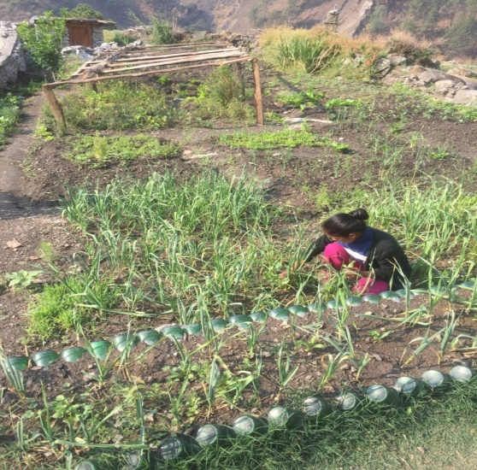
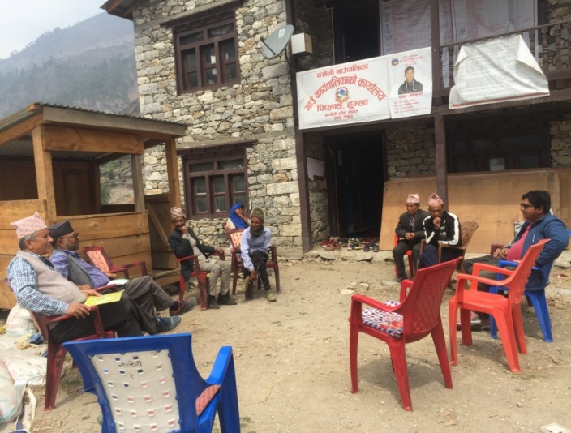

r+v]nL ufpFkflnsfdf sfo{s|d af/] 5nkmn –x'Dnf xf]d uf8]{gKn6df sfo{ ub}{ h'gf zfxL

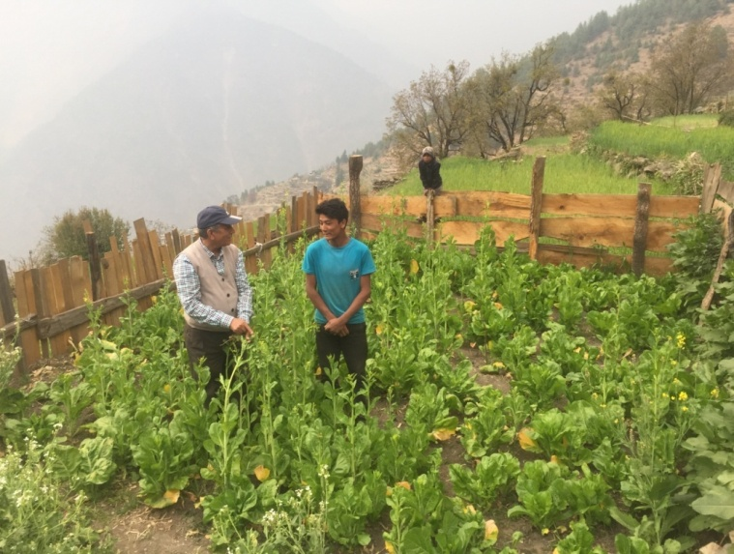
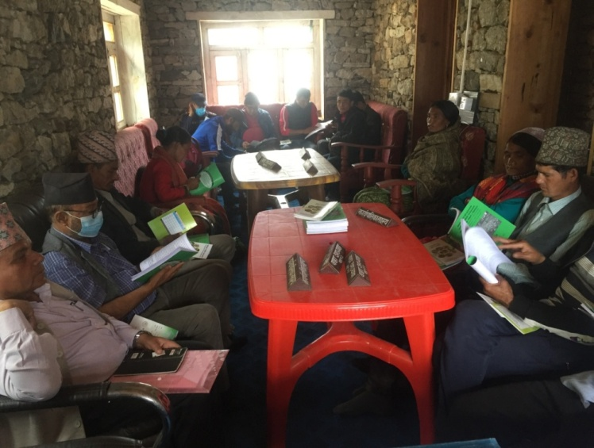

/fof]sf] lap pTkfbg sfo{s|d ldld x'Dnf x'Dnfsf] sfo{s|d x:tfGt/0f af/] 5nkmn

#=@ HIV prevention, care, support and treatment services among key populations in Chitwan and Nawalparasi East and Nawalparasi West Districts

s_ kl/ro
æ;xefuL Æ;+:yfn] USAID sf] cfly{s ;xof]udf ;g\ @))^ l8;]Da/ ! b]lv @)!! ;]K6]Da/ ;Dd lrtjg / gjnk/f;L lhNnfsf] /fhdfu{;+u hf]l8Psf uf=lj=;=df Pr=cfO=eL /f]syfd / pkrf/ ;DalGWf ;'/lIft /fhky hg:jf:Yo sfo{s|d / cS6f]a/ @)!! b]lv ;]K6]Da/ @)!^ ;Dd ;f]xL sfo{s|ddf kl/jf/ lgof]hgfsf ;]jfx? yk ul/ a;fFO{ ;/fO{ ug]{ ;d'xnfO{ ;d]t nlIft ul/ Plss[t kl/jf/ lgof]hg, Pr=cfO{=le= /f]syfd, pkrf/ / :ofxf/ ;]jf kl/of]hgf ;dfkg uof]{ . z'?jftdf o; sfo{s|dnfO{ cfzf kl/of]hgf / ;fy÷;fy k|f]h]S6n] ;xof]u ub]{ cfO{ /x]sf lyP . cS6f]a/ @)!^ b]lv ;]K6]Da/ @)@) ;Dd USAID/PEPFAR sf] ;xof]udf LINKAGES Nepal Project cGt{ut PrcfOeL /f]syfd, x]/rfx, ;xof]u / pkrf/ sfo{s|d ;~rfng u/]sf] ul/ cS6f]a/ @)@! b]lv EpiC kl/of]hgf ;+rfngdf /x]sf] 5 . of}gsdL{ dlxnf, of}gsdL{ dlxnfsf u|fxsx¿ / PrcfOeL ;+s|ldtx?nfO{ of}g / PrcfOeL /f]syfd ;DaGwL lZfIff, lgMz'Ns of}g /f]u / PrcfO{eL ;DalGw k/fdz{ tyf kl/If0f / pkrf/ ;]jf k|bfg ug'{sf ;fy} PrcfOeL ;+qmldtx?sf nfuL cj;/jfbL /f]uaf6 aRgsf] nflu cfjZos cf}ifwLsf] ;]jf / pkrf/ ;fIf/tf a9fpgsf nflu 3/ tyf ;d'bfod} lzIff k|bfg ub{} cfO/x]sf] 5 . xfn Pr cfO{ le sf] pRr hf]lvddf /x]sf JolQmx?nfO{ PrcfO{le af6 hf]lugsf] nflu Prevention sf] ?kdf PrEP cf}ifwLsf] klg z'?cft ul/;s]sf] 5 .

gofF ;+/rgf cg';f/ lrtjg lhNnfsf] e/tk'/df City Clinic / cGo :yfgdf cfjZostf cg';f/ Community Led Test (CLT) , Self Testing dfkm{t dlxnf of}gsdL, pgLx?sf u|fxsx?, k'?if ;dlnËL, k'?if of}gsdL{ -;dlnËL_ / t];|f lnËLnfO{ PrcfOeL kl/If0f ;]jf / k/fdz{ ;]jf dfkm{t of}ghGo ;+s|d0fsf] kl/If0f / pkrf/ / PrcfOeL ;+s|ldtx?nfO{ cj;/jfbL ;+s|d0f Joj:yfkgsf nflu ;]jf k|bfg ul/G5 .

v_ nIo
lrtjg / gjnk/f;L lhNnfdf dlxnf of}gsdL, pgLx?sf u|fxsx? / PrcfOeL ;+s|ldtnfO[ / k'?if ;dlnËL, k'?if of}gsdL{ -;dlnËL_ / t];|f lnËLsf nflu lrtjgdf PrcfOeL /f]syfd, x]/rfx, ;xof]u / pkrf/ ;]jf sfof{Gjog ug{ ;xof]u ug]{ .

u_ nlIft au{M dlxnf of}g sdL{ tyf ltgsf u|fxsx?
3_ kl/of]hgfsf lqmofsnfk
!= PrcfOeL /f]syfd, x]/rfx, ;xof]u / pkrf/ ;]jfdf kx'Fr j[l¢ ul/ PrcfOeL ;+s|ldtnfO{ pkrf/df lgoldt agfpg] M pRr hf]lvddf /x]sf] hg;+VofnfO{-of}gsdL{ dlxnf, ltgsf u|xfsx?, k'?if ;dlnËL, k'?if of}gsdL{ -;dlnËL_ / t];|f lnËL_ City clinic af6 PrcfOeL kl/If0f, of}g/f]u kl/If0f / pkrf/ / k|L Pcf/L6L ;]jf lbg], Clinic af6 kQf nfu]sf PrcfOeL ;+s|ldtnfO{ glhs}sf] Pcf/6L s]Gb|af6 pkrf/ lng ;xof]u ug]{ / lgoldt x'g d2t ug]{ / cGo cfjZlso ;]jf h:t} kLPd6Ll;6L, l6eL kl/If0f / pkrf/, efO/n nf]8 u0fgf / ;xof]u ug]{ Ù / PrcfOeL kl/If0f ;DaGwL gofF k|ljwL k|j{4g ug]{ / nfu' ug{ ;xof]u ug]{ .
@= of}gsdL{ dlxnf, ltgsf u|xfsx?, k'?if ;dlnËL, k'?if of}gsdL{ -;dlnËL_, t];|f lnËL / PrcfOeL ;+s|ldtx?df CoPCT ;]jfsf] dfu a9fpg] M ;L la P; dfkm{t dlxnf of}gsdL{ / pgLx?sf u|fxsx? Klxrfg ul/ hf]lvd Go'lgs/0f / s08d k|of]u / ;Demf}tf ;Lk l;sfpg] / PrcfOeL kl/If0f / of}g/f]usf] hfrFsf nflu k|]if0f ug]{ Ù kLo/ g]leu]6/ dfkm{t dlxnf of}gsdL{ a:g] gofF 7fpFx? klxrfg ug{, PrcfOeL kl/If0f / of}g/f]usf] hfrFsf nflu k|]if0f ug{ / s08d ljt/0f ug{ tflnd lbO{ kl/rfng ug]{ Ù PrcfOeLsf] nf~5gf 36fpg nf~5gf tyf e]befj Go'lgs/0f tflnd ;d'bfosf JolQm, ;/f]sf/jfnf / ;]jfu|fxLnfO{ k|bfg ug]{ .
#= of]hgf, ;'kl/j]If0f, ;j]{If0f / u'0f:t/ sfod ug{ k|jfnL ljsf; ug]{ M nlIft ;d'xsf] cg'dflgt ;+Vof kQf nufpg Rappid Community Assessment ug]{ Ù cg'dflgt ;+Vof, klxrfg, kl/If0f / pkrf/sf Gap kQf nufpg] Ùlgoldt tYofÍ ljZn]if0f ul/ sfo{s|d sfof{Gjogdf ;'wf/ ug]{ Ù lgoldt ;xof]ufTds ;'kl/j]If0f ul/ u'0f:t/ sfod /fVg] .
$= Home Based Care for COVID 19 Case Management in Chitwan District
;xeflu ;+:yfn] USAID/ARPA sf] cfly{s ;xof]udf km]a|'jl/ @)@@ b]lv Olks g]kfn kl/of]hgf cGtu{t sf]le8 !( sf] s]; Aoj:yfkgsf] nflu 3/df cfwfl/t ;]jf sfo{s|d ;~rfngdf /x]sf] 5.
r_ sfo{ If]q M
lrtjg, gjnk/f;L k"j{ / gjnk/f;L klVrd lhNnfsf ;a} ufp+kflnsfx? / gu/kflnsfx? nfO{ nlIft ul/ sfo{If]q jgfO{Psf] 5 .
h_ kl/of]hgfsf d'Vo ;+VofTds pknlAw -k|ult_
!_ nlIft ;d'bfonfO{ PrcfO{ eL, of}ghGo ;+qmd0f tyf pkrf/ ;DalGw lbPsf] lzIffsf] nIo tyf k|ultM
qm=;= | nlIft ;d'x | Jfflif{s  nIo | Jfflif{s  pknAwL | pknAwL  k|ltzt | s}lkmot
! | of}gsdL{ dlxnf | ##% | $!# | !@#
@ | of}gsdL{ dlxnfsf uf|xsx?, | @*) | %#@ | !()
@_ PrcfOeL ;+s|ldtnfO{ 3/ tyf ;d'bfodf e]63f6
qm= ;= | nlIft ;d'x | Jfflif{s  nIo | Jfflif{s  pknAwL | pknAwL k|ltzt | s}lkmot
! | PrcfOeL ;+s|ldt | #$( | ^^( | !(@
@_ of}g/f]u kl/If0f / pkrf/, :j]lR5s /Qm kl/If0f / Pr=cfO{=le ;+s|ldtx?sf] cTofjZolso :Jff:Yo ;]jfM
qm= ;= | nlIft ;d'x | Jfflif{s  nIo | Jfflif{s  pknAwL | pknAwL k|ltzt | s}lkmot
! | of}gsdL{ dlxnf | #^ | #$ | ($
@ | of}gsdL{ dlxnfsf u|fxsx?, | @* | @) | &!
# | k'?if ;dlnËL | @$ | ( | #*
$ | k'?if of}gsdL{ -;dlnËL_ | * | ^ | &%
% | t];f|] lnËL | ( | * | *(

#_ PrcfO{eL k/fdz{ / kl/If0f nIo tyf k|flKt

qm= ;= | nlIft ;d'x | Jfflif{s nIo | Jfflif{s  pknAwL | pknAwL k|ltzt | s}lkmot
! | of}gsdL{ dlxnf | @$$ | #$* | !$#
@ | of}gsdL{ dlxnfsf u|fxsx?, | !*( | @^) | !#*
# | k'?if ;dlnËL | !^# | @$) | !$&
$ | k'?if of}gsdL{ -;dlnËL_ | %$ | &$ | !#&
% | t];f|] lnËL | ^$ | *@ | !@*
^ | cGo
& | gof Pr cfO eL ;+s|ldt klxrfg | ^^ | ^& | !)@ | lrtjgdf %# dfq

$_ Pr=cfO{=le /f]syfdsf] nflu s08d lat/0fsf] ;+Vof

qm= ; | nlIft ;d'x | Jfflif{s nIo | Jfflif{s  pknAwL | pknAwL k|ltzt | s}lkmot
! | PLHIV , of}gsdL{ dlxnf / ltlgx?sf] u|fxs | %)*!* | @*(*)@ | %&)
%_ ;d"bfosf JolQmx?nfO{ nf~5gf / e]befj Go'gLs/0f tyf ;'/lIft of}g Jojxf/ ;DalGw tflndM
lhNnf | tfnLd | Jfflif{s nIo | Jfflif{s pknAwL | pknAwL k|ltzt
lrtjg | !@ | #)) | @^^ | *(

^_ sf]le8 !( la?4sf] vf]k nufpg ;xof]u
qm =; | sf]le8 !( la?4sf] vf]k nufpg ;xof]u u/]sf] hDdf vf]k s]Gb«x?
! | #$
&_ sf]le8 !( la?4sf] vf]kdf ;xof]u *_ sf]le8 !( kf]h]l6a AolQmx?nfO{ 6]lnx]Ny dfkm{t ;]jf
qm ;= | dlxnf | k'?if | cGo | hDdf
! | %# | %) | ! | !)$
qm =; | vf]ksf] k|sf/ | pknlAw
! | Kflxnf] dfqf | @^$$
@ | bf];|f] dfqf | ^((
# | a':6/ dfqf | $$$)
hDdf |  | &&*#
h_ k|d'v u'0ffTds pknAwL -k|ult_
- PrcfO{eL P8\;sf] If]qdf sfd ug]{ ;+3 ;:yf ;+u lgoldt ;Dks{ ;dGjo Pj+ ;xsfo{ .
- lgoldt ?kdf sfo{s|d k|ult k|ltj]bg ;/f]sf/jfnf ;:yfx? ;+u k|]z0f .
- ljZj P8\; lbj;, s08d lbj; h:tf lbgx?df lhNnf P8\; ;dGjo ;ldlt / ;/f]sf/jfnfx? ;+usf] ;dGjodf ;+o'Qm ?kdf hgr]tgf d'ns lqmofsnfkx? ;+rfng .
- nlIft ;d'xsf] Jojxf/ kl/jt{g Pj+ pkrf/ vf]hL ug]{ jflgsf] ljsf;sf] nflu nlIft ju{ jf6g} ;fyL lzIfssf] ?kdf kl/rfng tyf Ifdtf clej[l4 .
- k|yflds :jf:Yo s]Gb| jf6 klg ;]jf lj:tf/ sf] nfuL k|ls|of cuf8L a9fOPsf].
cfk|jf;L sfdbf/x? Wofgdf /flv Eff/t l;df If]qdf klg cfp6l/r ;]jf lj:tf/ .

em_ c;n cEof; / l;sfO{
o; kl/of]hgf cGt{ut ljleGg ;/sf/L tyf u}/;/sf/L ;+3 ;+:yfx?;Fu lgoldt e]63ft tyf ;Dks{, ;dfhdf PrcfOeL tyf of}g/f]u /f]syfd tyf pkrf/sf nfuL ;"rgf ;xh / l56f] ?kdf k'¥ofpgsf] nfuL @) hgf bf}t/L ;fyL lzIfsnfO{ tflnd tyf kl/rfng, s08ddf kx'Fr a9fpg ;fd'bflos ;"rgf s]Gb| dfkm{t s08d ljt/0f / k|]if0f, Plss[t ;]jf ;~rfngsf nflu ljleGg ;+3 ;:yfx?;Fusf] ;Dks{ tyf ;dGjo, dlxnf of}gsdL{nfO{ Jojxf/ kl/jt{g u/fpgsf nfuL plgx?nfO{ cfo cfh{gsf sfo{df ;+nUg u/fpgsf nflu ;dGjo h:tf cEof; tyf l;sfO{x? eP .

kl/of]hgf cGt{utsf s]lx tl:j/x?
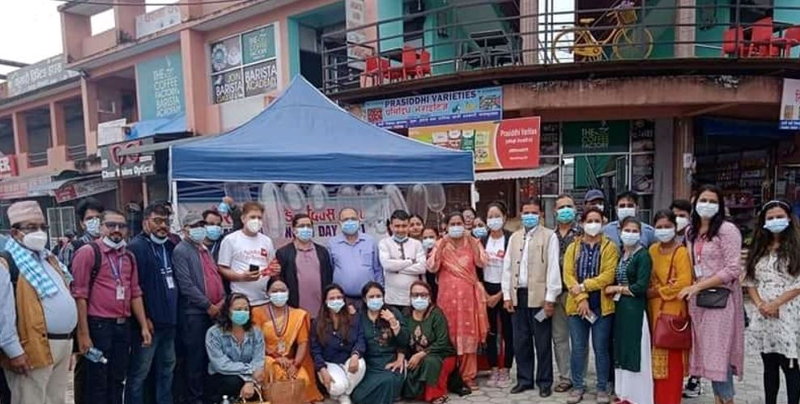
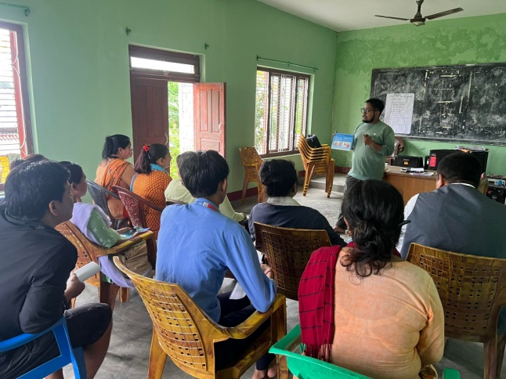
nfG5gf tyf e]befj Go"lgs/0f tflnd –/fKtL gkf .

llrtjgdf #$cf}+ ljZj P8\; lba; dgfpb} .

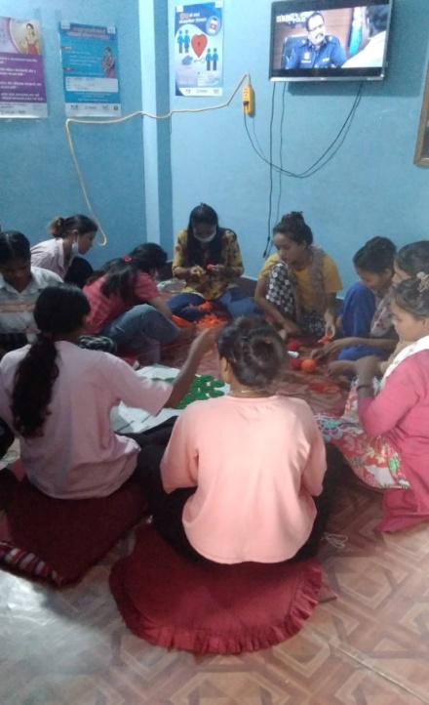
l;kd'ns sfo{s|d cGtu{t nlIft ju{nfO wfuf]af6 km'n agfpg l;sfOb} .

#=#= :yfgLo emf]n'Ë] k'n lgdf{0f sfo{qmddf k|fljlws ;]jf tyf ;fd'bflos kl/rfng M:yfgLo emf]n'Ë] k'n lgdf{0f sfo{qmd, lrtjg(Bridge Building at Local Level-Program, Chitwan)

s_ kl/ro
lrtjg lhNNffsf kxf8L uf=lj=;=x?df vf]nf tyf gbL cfjt hfjt ug{ c;'ljwf ePsf]n] emf]n'ª] k'nsf] dfu a9\b} cfO/x]sf] 5 . k/Dk/fut?kdf cfjt hfjtsf nflu ckgfOPsf ljleGg dfWodx? dfgljo Ifltsf lx;fan] ;+j]bglzn x'g] / jiff{tsf] ;dodf tL pkfox? k|efjsf/L gx'g] x'bf klg To:tf If]qdf o;sf] dfu a9\b} uPsf] xf] .
:yfgLo :jfoQ zf;g P}g, @)%% / lgodfnL, @)%^ sf] dd{ adf]lhd :yfgLo k"jf{wf/ gLlt @)^! sf] sfof{Gjog tyf emf]n'Ë] k'n /0fgLlt @)^@ adf]lhd emf]= k'= lgdf{0f tyf dd{t ;+ef/ sfo{df k|fljlws tyf ;fdflhs kl/rfngsf] nflu u}/;/sf/L If]qnfO{ kl/rfng u/fpg] ;/sf/sf] gLlt cg'?k v'Nnf k|ltZkwf{jf6 cf= j= @)^!÷)^@ df 5gf]6 eO{ xfn ;Dd ;xefuL ;+:yfn] lrtjg lhNnf ljsf; ;ldltsf] ;xof]uL ;+:yfsf] ?kdf lg/Gt/ sfo{ ub}{ cfPsf] 5 .
lrtjg lhNnf ljsf; ;ldlt, lhNnf ;dGjo ;ldlt tyf lhNnf k"jf{wf/ sfof{no lrtjgåf/f ljleGg cf= j= x?df ePsf] sfo{ k|Tofof]hg cg';f/ lhNnfdf xfn ;Dd &! j6f emf]= k'= x?sf] lgdf{0f ;DkGg ePsf] 5 .
v_ emf]n'Ë] k'nx?sf] sfof{b]z k|fKt eP adf]lhd ;DkGg ePsf k'n ;d'bfodf x:tfGt/0f ul/Psf 5g\ eg] cGosf] lgdf{0f sfo{ rfn' 5 .
qm; | emf]n'Ë] k'nx?sf] gfd | uf=kf÷g=kf j8f g+= |  | cg'dflt nfut ?= | cj:yf
 |  | 7]ufgf | nDjfO{
! | aDa'6f/ emf]= k'= | /fKtL–!! | !)#=)) ld= | NPR.43,72,179.15 | ;DkGg
@ | jfsGtL emf]= k'= | /fKtL–!) | ^#=)) ld= | NPR.29,20,288.42 | ;DkGg
# | so/vf]nf emf]= k'= | sflnsf–)* | *)=)) ld= | NPR.64,88,624.22 | ;DkGg
$ | j}s'G7wfd emf]= k'= | dfl8–)* | *(=)) ld= | NPR.38,99,189.44 | ;DkGg
% | cf;fvf]nf emf]= k'= | O{R5ffsfdgf–)@ | %*=^) ld= | NPR.31,23,501.33 | ;DkGg
^ | 3f]/jfË emf]= k'= | sflnsf–)( | &^=)) ld= | NPR.67,62,197.70 | Rffn'
& | b}|fkltgu/ emf]= k'= | dfl8–)! | !@)=)) ld= | NPR.85,34,772.98 | Rffn'
c.=j )&*.&( sf sfof{b]z k|fKt eO{ lgdf{0f sfo{sf nflu l:js[t k'nx?
! | tfNtL vf]nf emf]=k'n | OR5fsfdgf–^ | **=)) ld= | NPR 3905825.17 | Rffn'
@ | yfk|fËltkfË emf]=k'n | OR5fsfdgf–! | &@=)) ld= | NPR 3338343.00 | Rffn'
# | jfª\Uofª emf]=k'n | OR5fsfdgf–! | &%=)) ld= | NPR. 3754663.18 | Rffn'
$ | /;f}nLl;¢L emf]= k'n | /fKtL–( | ^%=)) ld= | NPR 4975305.79 | Rffn'
% | jfs|fËkvf{n emf]=k'n | /fKtL –!@ | ^#=)) ld= | NPR 2914786.41 | Rffn'
^ | dftf{nvf]nf emf]=k'n | /fKtL –!! | ^&=)) ld= | NPR 3611901.02 | Rffn'
& | a8x/]vf]nf emf]=k'n | sflnsf –( | %(=)) ld= | NPR 2179432.27 | Rffn'
c.=j )&(.*) sf nflu sfof{b]z k|fKt eO{ lgdf{0f sfo{sf nflu l:js[t k'nx?
! | jfË;L/fª emf]n'Ë] k'n | /fKtL– !),!@ | &@=)) ld= | NPR.5700000 | DPR agfpg] s|ddf /x]sf]
@ | dft{n -v_ emf]n'Ë] k'n | /fKtL –!! | &%=)) ld= | NPR.3700000 | Æ
# | u}8f3f/L emf]n'Ë] k'n | sflnsf –( | ^%=)) ld= | NPR.6600000 | Æ
$ | b]ph/ emf]n'Ë] k'n | sflnsf –!) | ^#=)) ld= | NPR.5200000 | Æ
% | ;ldnwfk emf]n'Ë] k'n | OR5fsfdgf –& | ^&=)) ld= | NPR.6600000 | Æ
^ | nfnk;f{3f6 emf]=k'n | /=g=kf– ( | %(=)) ld= | NPR.6600000 | ;e]{ ug]{

u_ k'n lgdf{0f ;DjGwL s]lx tl:j/

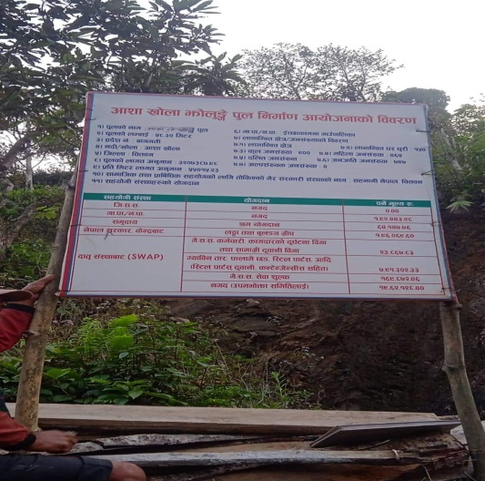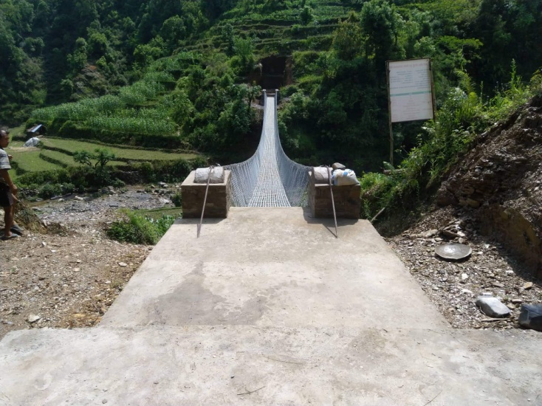
of]hgf ;'rgf kf^L cfzfvf]nf tof/L k'n–OR%fsfdgf

#=$= s[lif cg';Gwfg kl/of]hgf
pNn]lvt kl/of]hgf s[lif cg';Gwfgdf s]lGb|t /x]sf] 5 .;f] kl/ofhgfsf] cWooglaifo“Drivers of Safer Food Production and Consumption in Nepal: Understanding the Adoption of Food Safety Practices and Consumer Consciousness in Fresh Produce”/x]sf] 5 .kl/ofhgfsf] bft[lgsfo cd]l/sf l:yt Purdue laZjlaWofnodf cjl:yt USAID 4f/f cfly{s ;xof]u u/]sf] km"8 ;]lkm\6L Ogf]e];g Nofj /x]sf] 5 .pQm kl/of]hgf ;+o'Qm ?kdf ;xefuL ,s[lifaglaZjlaWofno /fdk'/,lrtjg / cd]l/sfsf] Tenesse State Universitysf] ;xefuLtfdf ;Grfng ul/Psf] 5 .
- kl/of]hgfsf] gfd M s[lif cg';Gwfg kl/of]hgf
- sfo{If]q Mlrtjg,dsjfgk'/,?kGb]xL ,sf7df08f} / sf:sL
- kl/of]hgfcjlw M@ aif{ -! dfr{ @)@@ b]lv @* km]a|'c/L @)@$ ;Dd_
- nlIft ;d'bfo M vfWofGg pTkfbs /pkef]Qmf
- nfeflGjt ;+Vof M%&) 3/w'/L
- k|:tljt ah]6 ?=%%,$!,)))=))
- bft[lgsfo M Food safety Innovation Lab, USA

$=cWoog tyf cg'zGwfgfTds sfo{s|d

$=! sf]le9 –!( n] hgtfdf kf/]sf] k|efj af/] cWoog ePsf] 5 .

%= k|sfzgx? (Publications)

s_ jflif{s Sofn]08/ -uf]hL kfqf] _
;+:yfn] sfof{Gjog ub]{ cfPsf sfo{s|dx?nfO{ Jojl:yt / of]hgfj4 lsl;daf6 ;~rfng ug{sf nflu @)&* sf] jflif{s Sofn]08/ (Year Planner) k|sfzg ul/ ;+:yfsf ;fem]bf/ tyf ;/f]sf/jfnf lgsfox? P+j z'elrGtsx?nfO{ ljt/0f ul/Psf] 5 . o; uf]hL kfqf]n] ;+:yfsf] ;+lIfKt lrgf/L, sfo{s|dx?sf] ljj/0f, dxTjk'0f{ ;Dks{ gDa/ nufot @)&* ;fnsf] Sofn]08/nfO{ ;d]6]sf] 5 . o;sf] k|sfzgaf6 sfo{s|d ;~rfngdf ;xhtf / ;Dks{, ;dGjo / ;+:yfut k|rf/ k|;f/df ;xof]u k'u]sf] 5 .

v=_ a[Qlrq tof/ M
o; cfj )&*÷)&(df ;+:yf :yfkgfsfn b]lv xfn ;Dd ;+:yf4f/f laleGg lhNnfdf ;~rfng ub}{cfPsf / u/]sf sfo{s|dsf] af/]df sl/j $) dL=sf] laQ lrq lgdf{0f ul/Psf] 5 .

^= :jLs[t sfo{qmd tyf ah]6 cg';f/ vr{ k|ult

;+:yfsf] aflif{s n]vfkl/If0f k|ltj]bgdf la:t[t ?kdf /x]sf] / ;f] k|ltj]bg ;+:yfsf] website: www.sahavagi. org.np k9\g tyf 8fpgnf]8 ug{ ;lsG5 . ljQLo ;f/f+z, jff;nft tyf cfo Joo ljj/0f jflif{s n]vf k/LIf0f k|ltj]bg cf=j= @)&*÷)&( jf6 k|fKt ug'{x'g cg'/f]w 5 .
&= cf= j= @)&(÷)*) sf] k|:tfljt sfo{s|d tyf ah]6
cfufdL aif{sf nflu o; aif{ ;+rflnt sfo{s|dx?sf] lg/Gt/tf :j?k lgDgfg';f/sf sfo{s|d /x]sf 5g\ .
Income and Expenditure FY 2079/080
Description | Total Income | Total Expenditure | Net Income | Remarks
FASEC | 5,541,000.00 | 5,541,000.00 | 0
EpiC | 15,000,000.00 | 15,000,000.00 | 0
New Project | 3,000,000.00 | 3,000,000.00 | 0 | -
SSTB | 2,200,000.00 | 1,925,000.00 | 275,000.00 | Operational saving from 6% of total project cost
Income of Central Office (Overhead ,Interest,Membership Fee,Land Rent ) | 809,100.00 | 824,500.00 | -15,400.00 | Salary payment to night guard and accountant.
Net Operational Surplus | 26,550,100.00 | 26,290,500.00 | 259,600.00

Tentative Budget Summary (FY 079/080)
Project Budget ( Program Cost ) | 25466000 | 96.86
Central Office Budget (opretional Cost ) | 824500 | 3.13
Total Budget | 26290500 | 100%

*= cf= j= @)&*÷)&( df ;~rflnt sfo{s||d
qm ; | sfo{qmd | ;xof]uL ;+:yf | s}lkmot
! | :yfgLo cfTdlge{/ sfo{qmd,x'Dnf | - kmf:6gf]km/ -l:j; $) lbg] pkjf; sf]if _ | @)&* sflt{s !%;Dd
@ | Plss[t kl/jf/ lgof]hg, Pr=cfO{=le=/f]syfd, pkrf/ / :ofxf/ sfo{s|d lrtjg / gjnk/f;L | USAID/FHI-36o -ln+s]h]h÷Olks g]kfn kl/of]hgf_ | lg/Gt/
# | :yflgo ´f]n'Ë] k'n lgdf{0f sfo{qmd, lrtjg | :yfgLo kflnsfx? lrtjg l6=lj=P;=o'=, x]Ne]6f; | lg/Gt/
$ | s[lif cg';Gwfg kl/of]hgf | Food safety Innovation Lab, USA | @)&* r}q af6 z'? kf}if ;dd dfq .

(= ;+u7gfTds 9fFrf - संस्था संरचना )
साधारण सभा

संचालक समिति

उपसमिति/विभाग

अध्यक्ष
स्थानीय झोलुंगे पुल निर्माण कार्यक्रम
१. जनशक्ति व्यवस्थापन विभाग
२. अनुगमन तथा मुल्यांकन विभाग
३. अध्ययन अनुसन्धान विभाग
४. प्रशिक्षण विभाग

केन्द्रीय कार्यालय

कार्यालय प्रमुख

फासेक परियोजना

१. अनुसन्धान तथा मुल्यांकन समिति

२. संस्थागत समिक्षा बोर्ड (IRB)
शाखा कार्यालय
१. बर्दघाट
२. भरतपुर १० स्याउलीबजार

एच. आइ. भी. एड्स रोकथाम हेरचाह सहयोग तथा उपचार कार्यक्रम

