;xefuL
Afflif{s k|ult k|ltj]bg

cf= j= @)&(÷)*)

k|sfzsM
s]GbLo sfof{no
/Tggu/ gu/kflnsf–(,l9s'jf,lrtjg
kmf]g g+= )%^–^!#%#
O{d]n: sahavagico@sahavagi.org.np
j]e ;fO{6M www.sahavagi.org.np

sfo{s

ljifo;"rL
ljifo;"rL -k]h g+= cg';f/_
! | ;+:yfut emns | #
@ | kl/ro | $
# | sfo{d"ns sfo{qmdx? | ^
#+=! | PrcfOeL= /f]syfd, x]/rfx, ;xof]u / pkrf/ sfo{s|d, lrtjg, gjnk/f;L k'j{ tyf gjnk/f;L klZrd | ^
#=@ | :yfgLo emf]n'Ë] k'n lgdf{0f sfo{qmd lrtjg | (
#=# | s[lif cg';Gwfg kl/of]hgf | !!
#=$ | cWoog cg';GwfgfTds sfo{qmd | !@
$ | k|sfzgx? | !@
^ | cf=a= @)&(÷)*) sf] :jLs[t sfo{qmd tyf jh]6 tyf n]vfkl/If0f k|ltj]bg | !@
& | cf=j= @)&(÷)*) df ;~rflnt sfo{qmdx? | !#
* | cf=j= @)*)÷)*! sf] k|:tfljt sfo{qmd tyf jh]6 | !#
( | ;+:yfsf] ;+u7gfTds 9f+rf | !$

!= ;+:yfut emns

sfg'gL cl:tTj
:yfkgfM lj=;= @)%# - O{=;= !((&_
btf{M lh=k|=sf=, lrtjg
btf{ g+ M !)# . )%# . )%$
btf{ ldltM @)%# . !@ . @%
;=s=k=cfM @)%^ . $ . !$

cflwsf/Ls ;+/rgf
;fwf/0f ;efM k|To]s jif{ clgjfo{ ?kdf
sfo{;ldltM ( ;b:ox?
-# dlxnf, $ k'?if, ! blnt, ! hghflt_
;fwf/0f ;b:oM @& hgf

dfga ;fwg
hDdf sd{rf/L M @* -k'?if– * ,dlxnf–@)_
s]lGb|o sfof{noM &
zfvf sfof{nox?dfM @!

sfo{cjlw
jflif{s ;fwf/0f ;efM k|To]s jif{
sfo{;ldltsf] sfo{sfnM tLg jif{
sfo{;ldlt a}7sM k|To]s tLg tLg dlxgfdf

jt{dfgdf ;xsfo{ ul/Psf ;fem]bf/ ;+:yfx?
USAID/EpiC kl/of]hgf
s[lif cg';Gwfg kl/of]hgf
:yfgLo emf]n'Ë] k'n sfo{s|d
lrtjgsf ;a} kflnsfx? -ufpmkflnsf tyf gu/kflnsfx?_
ljutdf ;xsfo{ ul/Psf ;fem]bf/ ;+:yfx?
kmf:6]gf]km/
x]Ne]6f; g]kfn
USAID/EpiC
;fy ;fy kl/of]hf÷Pkm=Pr=cfO=#^) g]kfn
PlzofnL ljsf; a}+s÷ci6«]lnog g];gn=o'lgel;{6L
lh=;=;= lrtjg
e/tk'/ c:ktfn
cS;kmfd lh=lj=
o'=P;=P=cfO{=l8=
o'= Pg= j'dg
lrtjgsf ;a} kflnsfx? -ufpmkflnsf tyf gu/kflnsfx?_

@= kl/ro

@= ! ;+:yfut kl/ro
æ;xefuLÆ :jfjnDjg / ;xeflutfTds ljsf; k4ltdf ljZjf; /fVg] / o;} k4ltdf nfdf] sfo{ut cg'ej ePsf Joj;flos lj1x?åf/f :yflkt Pp6f ;fdflhs ;+:yf xf] . of] ;+:yf lhNnf k|zf;g sfof{no lrtjgdf @)%# ;fn r}q @% ut] -;g=!((&_ ;fdflhs ;+3÷;+:yf btf{ P]g, @)#$ cGtu{t btf{ ePsf] 5 . o;}u/L ;dfh sNof0f kl/ifb\ -*(&!_, cfGTfl/s /fh:j sfof{no -kfg g+ M #))##$$##)_, Uf}=;=;= lrtjg -#)%–@)%*÷%(_, u}=;=;= dxf;+3 (C.R.CHI-27), k|hftflGqs u}=;=;= dxf;+3 g]kfn (FEDEN), P8\; lj?4 /fli6«o g]6js{ ;d"x g]kfn (NANGAN) / g];f] lrtjg -!_ df btf{ tyf cfj4 e};s]sf] 5 .
of] ;+:Yff ;xeflutf / ;fem]bf/Ldf ljZjf; ub{5 . ;xeflutfTds ljsf;sf] nflu ;/sf/L, ;fdflhs, gLlh, /fli6«o, cGt/fli6«o, ax'/fli6«o ;+3 ;+:yf / ;d'bfosf dflg;x?;+u ldn]/ ;fem]bf/Ldf sfd ug]{ OR5f /fVb5 . o;n] cfkm\gf] cg'ejnfO{ o:t} If]qdf sfd ug]{ cGo ;+3 ;:yfx?;Fu cfbg k|bfg ug{ rfxG5 .

cfly{s, ;fdflhs tyf /fhg}lts ?kn] ljkGg ju{sf] ?kdf /x]sf dlxnf, l;dfGt kl/jf/, blnt tyf hg hfltx?sf] cfTd ljsf;sf] nfuL pgLx?nfO{ g} ;zQm agfO{ ljsf;sf] d"nwf/df ;xefuL x'g] jftfj/0fsf] ;[hgf ug'{ jt{dfg ;dosf] cfjZostf xf] . k|To]s dflg;df cGt/lglxt Ifdtf / zlQmnfO{ l7s tl/sfn] klxrfg u/L kl/rfng ug{ d4t k'¥ofOof] eg] dfgj dfqsf] ;jf{lË0f ljsf;df 6]jf k'Ug ;Sb5 eGg] dfGotfdf ;xefuLn] ljZjf; /fVb5 . To;}sf/0f ljsf; k|lqmofdf kl5 k/]sf cyjf g;d]l6Psf ljkGg ju{x? h:t} dlxnf, blnt ;d"bfosf dflg;x?;+u ldn]/ sfd ug{ rfxG5 . o; cltl/Qm cfkm\gf] cg'ej / bIftfnfO{ ljkGg ju{df /x]sf ;d"bfosf dflg;x?sf] kIfdf pkof]u ug{ OR5's cGo ;+3 ;+:yf, g]kfn ;/sf/ tyf cGt/f{li6«o ;+:yfx?;+u klg ;fem]bf/Lsf] ?kdf sfd ug{ rfxG5 .

lj=;= @)%# ;fndf :yfkgf ePsf] ;xefuL ;+:yfn] ljkGg ju{sf dflg;x?, ljz]if ul/ blnt, dlxnf / l;dfGts[t kl/jf/nfO{ ;xefuLtfTds ljsf; k|lqmofdf ;+nUg u/fpb} p2]Zod'ns tyf ldl>t ;d"x u7g ul/ :yfgLo ;+:Yffsf] dfWodaf6 ;dflhs / clfy{s ljsf;sf] nflu r]tgf, clej[[l4, dlxnf :Jff:Yo, ef}lts k"jf{wf/ tyf cfo cfh{gsf sfddf ;+nUg x'b} cfO/x]s]f 5 . sfo{d"ns sfo{s|dsf] cg'ejaf6 k|fKt / ;LknfO{ gLltut, cWoog, cg'zGwfg, tflnd, uf]i7L tyf k|sfzgsf] dfWodaf6 ;/f]sf/jfnf ;+3 ;:Yff / cfd ;d'bfo ;dIf k'/\ofPsf] 5 .

;+:yf :yfkgfsf] !) jif{ k'u]sf] cj;/df /0fg}lts of]hgf th'{df ul/ ;+:yfn] ljut b]lv /fv]sf] kl/sNkgf, Wo]o, nIf / p2]Zodf s]lx kl/dfh{g ;d]t u/]sf] 5 . b]zsf] kl/jlt{t /fhg}lts ;+be{, ;+l3o u0ftflGqs /fHo Joj:yfsf] zlQm ;+/rgfdf ;lhn} kx'Fr k'Ug g;Sg] / ljsfzsf] k|ltkmn kfpg af6 6f9} /x]sf ljkGg Pj+ jl~rt ju{sf] ;jf{ËL0f ljsf;sf] nfuL ;xeflutfTds k¢lt åf/f ;zlQms/0fdf of]ubfg k'/\ofpg' kg]{ cfjZostfnfO{ kl/dfh{g ul/Psf VMGO n] cfTd;fy u/]sf] 5 . ;+:yfn] xfn cjnDjg u/]sf] kl/sNkgf, Wo]o, nIo / p2]Zo lgDg cg';f/ 5g\ .

s_ kl/sNkgf
;fdflhs ?kdf ;f}xfb{ / cfly{s ?kn] cfTdlge{/ ;dfhsf] lgdf{0f .
v_ Wo]o
zlQm ;+/rgfdf kx'Fr gePsf / ljsfzsf] k|ltkmn kfpg af6 6f9} /x]sf ljkGg Pj+ jl~Rft ju{sf] ;xeflutfTds k¢ltåf/f ;zlQms/0fdf of]ubfg k'¥ofpg] .
u_ nIo
zlQm ;+/rgfdf kx'Fr gePsf, ljkGg, u/Lj, blnt, kLl8t tyf dlxnfx?nfO{ ;xefuLtfTds k|lqmofdf ;+nUg u/fO{ ;d'Ggt ;dfhsf] lgdf{0f ug'{ .
3_ p2]Zo
- ul/j, l;dfGt kl/jf/, blnt, kLl8t ju{ / dlxnfx?nfO{ ;xefuLtfd'ns ljsfz k|ls|ofdf ;+nUg u/fO{ plgx?sf] ;fdflhs tyf cfly{s :t/ psf:g] .
- ul/j / dlxnfx?;Fu sfd ug]{ ljwL / k|ls|of ;d]l6Psf gd'gf nfos sfo{s|dx?sf] ljsfz ug]{ .
- b]z ljsfzdf ul/j, ;LdfGt kl/jf/, blnt, kLl8t ju{ / dlxnfx?sf] ;zlQms/0fsf] nflu cg';GwgfTds sfo{ tyf cu'jfO{ ug]{ .

@=@ sfo{ gLlt
- nlIft ;d"bfosf dflg;x?df ;fd"lxs efjgf tyf :jfjnDag ljsf;sf] nfuL r]tgf clea[l4 tyf ;+:yfut ljsf;sf sfo{qmd ;+rfng ug]{ .
- ufp+m, lhNnf tyf /fli6«o :t/df tflnd, sfo{zfnf uf]i7L, cGt/lqmof / ;]ldgf/x?sf] cfof]hgf u/L ;xeflutfTds sfo{ k|0ffnLsf cg'ejx? cfbfg k|bfg ug]{ .
- n}lËs ,hft hflt tyf ul/jd"lv gLlt tyf sfo{qmdsf nfuL cu'jfO{ tyf ;Nnfx k|bfg ug]{ .
- :yfgLo :t/df cfjZostf cg';f/ ;xeflutfTds cfod"ns tyf l;k ljsf;sf tflnd cof]hgf ug]{ .

@=# lgb]{zs l;4fGtx?
- æ;]jsn] ;'v / duGt]n] dfg gvf]Hg' t/ :jfledfg gu'dfpg'Æ
- ælgbfPsfnfO{ ljpemfpg ;lsG5 t/ lgbfPsf] jxfgf ug]{nfO{ sl7g kl/>d ug'{kb{5Æ
- æsfo{stf{ Pp6f gd"gf kfq xf], hf] g}lts?kn] rl/qjfg x'G5, ;/n hLjg ofkg ub{5 / sfddf st{Jolgi7 x'G5Æ

@=$ cfrf/–;+lxtf
;+:yfdf sfo{/t sfo{stf{÷ sd{rf/L n] kfngf ug'{kg]{ g}lts lgod tyf ;'/Iffsf sfo{x?
!=lgb]{zs l;4fGtx?sf] k"0f{?kdf kfngf ug]{ .
@=;fj{hlgs :yfg, sfo{qmd jf sfo{fnodf s'g} klg /fhgLlts ljifodf 5nkmn, ax; jf 6Lsf6LKk0fL gug]{ .
#=sfo{qmdsf] nIo, p2]Zo / k|lqmof af/] s;}n] hfgsf/L dfu]df lzi6 / ;Eo efiffdf ;a} s'/f kf/bzL{ lsl;dn] a'emfO{ lbg] .
$=;+:yfsf ;+rfns ;ldltsf kbflwsf/L af/] ;f]wvf]h / hfgsf/L dfu]df yfxf ePsf] s'/fdfq :ki6 egL lbg] .
%=åGåsf] ;dodfdf åGådf ;+nUg kIf÷ljkIfsf s'/f j;f/ k;f/df gnfUg] .
^=bft[ ;+3 ;+:yfsf ;DaGwdf cfjZos / cfkm"nfO{ yfxf ePsf] eGbf a9L s'/f gjf]Ng] .
&=lkmN8df e|d0f ubf{ ;'/Iffsf] l:ylt a'em]/ dfq ug]{ .
*=;Defljt b'3{6gfnfO{ Wofgdf /fvL ;a} sd{rf/Lx?sf] b'3{6gf ljdf of]hgfnfO{ lg/gt/tf lbg]
(=sfo{ If]qdf s'g} ck|Toflzt 36gf 36\g uPdf s]Gb|Lo sfof{no jf ;DalGwt kbflwsf/LnfO{ t'?Gt ;"rgf ug]{ .
!)=;fdflhs ;+:yf dfxf;+3-NGO Federation Nepal_ 4f/f tof/ ul/Psf] cfrf/ ;+lxtf tyf g]kfndf sfo{/t cGt/fli6«o lgsfoåf/f k|sflzt lgb]{zs l;4fGt ;d]tnfO{ cfbf/ / ;Ddfg ug]{ .

@=% Joj:yfkg tyf ;+rfng
“;xefuL” sf] Joj:yfkg / ;~rfngsf nflu ( hgfsf] sfo{ ;ldlt 5 . hf] k|To]s # jif{sf] nflu ;fwf/0f ;efaf6 lgjf{lrt x'G5 . jif{df ;fdfGotof $ k6s sfo{ ;ldltsf] j}7s a:b5 . ;+:yfsf] hgzlQm Joj:yfkg / kl/of]hgfx?sf] cg'udg tyf d"Nofs+gsf] nflu 5'§} pkl;ldlt /x]sf 5g\ . ;+:yfsf] s]lGb|o sfof{no, /=g=kf= ( lrtjg, / lkmN8 sfof{nox? gjnk/f;Lsf] jb{3f6, e/tk'/ :ofpnL ahf/ xflsdrf]s /x]sf 5g\ . b}lgs sfo{ ;~rfngsf] nflu cfjZos kg]{ ljB'lto pks/0fx? tyf cGo ef}lts ;'ljwfx? k|ofKt dfqfdf /x]sf 5g\ .

#= sfo{d'ns sfo{s|d -Action Programmes)

#=!= HIV prevention, care, support and treatment services among key populations in Chitwan and Nawalparasi East and Nawalparasi West Districts
-Pr=cfO=eL= /f]syfd, x]/rfx, ;xof]u / pkrf/ sfo{s|d -lrtjg, gjnk/f;L k'j{ tyf gjnk/f;L klZrd_
s_ kl/ro
æ;xefuL Æ;+:yfn] USAIDsf] cfly{s ;xof]udf ;g\ @))^ l8;]Da/ ! b]lv @)!! ;]K6]Da/ ;Ddlrtjg / gjnk/f;LlhNnfsf] /fhdfu{;+u hf]l8Psf uf=lj=;=dfPr=cfO=eL /f]syfd / pkrf/ ;DalGWf ;'/lIft /fhkyhg:jf:Yosfo{s|d / cS6f]a/ @)!! b]lv ;]K6]Da/ @)!^ ;Dd ;f]xLsfo{s|ddf kl/jf/ lgof]hgfsf ;]jfx? ykul/ a;fFO{ ;/fO{ ug]{ ;d'xnfO{ ;d]t nlIftul/ Plss[t kl/jf/ lgof]hg, Pr=cfO{=le= /f]syfd, pkrf/ / :ofxf/ ;]jf kl/of]hgf ;dfkguof]{ . z'?jftdf o; sfo{s|dnfO{ cfzf kl/of]hgf / ;fy÷;fyk|f]h]S6n] ;xof]u ub]{ cfO{ /x]sflyP . cS6f]a/ @)!^ b]lv ;]K6]Da/ @)@) ;DdUSAID/PEPFARsf] ;xof]udfLINKAGES Nepal ProjectcGt{utPrcfOeL /f]syfd, x]/rfx, ;xof]u / pkrf/ sfo{s|d ;~rfng u/]sf] ul/ cS6f]a/ @)@! b]lvEpiC kl/of]hgf ;+rfngdf /x]sf] 5 . of}gsdL{ dlxnf, of}gsdL{ dlxnfsfu|fxsx¿ / PrcfOeL ;+s|ldtx?nfO{ of}g / PrcfOeL /f]syfd ;DaGwLlZfIff, lgMz'Ns of}g /f]u / PrcfO{eL ;DalGw k/fdz{ tyf kl/If0f / pkrf/ ;]jfk|bfgug'{sf ;fy} PrcfOeL ;+qmldtx?sfnfuLcj;/jfbL /f]uaf6 aRgsf] nflucfjZoscf}ifwLsf] ;]jf / pkrf/ ;fIf/tf a9fpgsf nflu 3/ tyf ;d'bfod} lzIffk|bfgub{} cfO/x]sf] 5 . xfnPrcfO{ le sf] pRrhf]lvddf /x]sfJolQmx?nfO{ PrcfO{le af6 hf]lugsf] nfluPreventionsf] ?kdfPrEPcf}ifwLsf] klg z'?cftul/;s]sf] 5 .

gofF ;+/rgfcg';f/ lrtjglhNnfsf] e/tk'/dfCity Clinic / cGo :yfgdfcfjZostfcg';f/ Community Led Test (CLT) , Self Testingdfkm{t dlxnf of}gsdL, pgLx?sfu|fxsx? TyfcGopRrhf]lvddf /x]sfAolQnfO{ PrcfOeL kl/If0f ;]jf / k/fdz{ ;]jfdfkm{t of}ghGo ;+s|d0fsf] kl/If0f / pkrf/ / PrcfOeL ;+s|ldtx?nfO{ cj;/jfbL ;+s|d0f Joj:yfkgsfnflu ;]jfk|bfgul/G5 .
v_ nIo
lrtjg / gjnk/f;LlhNnfdfdlxnf of}gsdL, pgLx?sfu|fxsx? / PrcfOeL ;+s|ldtnfO[ / k'?if ;dlnËL, k'?if of}gsdL{ -;dlnËL_ / t];|f lnËLsfnflulrtjgdfPrcfOeL /f]syfd, x]/rfx, ;xof]u / pkrf/ ;]jfsfof{Gjogug{ ;xof]u ug]{ .
u_ nlIft au{M dlxnf of}gsdL{ tyf ltgsfu|fxsx?

3_ kl/of]hgfsf lqmofsnfk

!=PrcfOeL /f]syfd, x]/rfx, ;xof]u / pkrf/ ;]jfdfkx'Fr j[l¢ ul/ PrcfOeL ;+s|ldtnfO{ pkrf/dflgoldtagfpg] M pRrhf]lvddf /x]sf] hg;+VofnfO{-of}gsdL{ dlxnf, ltgsfu|xfsx?_City clinic af6PrcfOeL kl/If0f, of}g/f]u kl/If0f / pkrf/ / k|LPcf/L6L ;]jflbg], Clinic af6 kQfnfu]sfPrcfOeL ;+s|ldtnfO{ glhs}sf] Pcf/6L s]Gb|af6 pkrf/ lng ;xof]u ug]{ / lgoldtx'g d2t ug]{ / cGocfjZlso ;]jf h:t} kLPd6Ll;6L, l6eL kl/If0f / pkrf/, efO/n nf]8 u0fgf / ;xof]u ug]{ Ù / PrcfOeL kl/If0f ;DaGwLgofFk|ljwLk|j{4g ug]{ / nfu' ug{ ;xof]u ug]{ .
@=of}gsdL{ dlxnf, ltgsfu|xfsx? / PrcfOeL ;+s|ldtx?df CoPCT ;]jfsf] dfu a9fpg] M ;L la P; dfkm{t dlxnf of}gsdL{ / pgLx?sfu|fxsx? Klxrfgul/ hf]lvdGo'lgs/0f / s08d k|of]u / ;Demf}tf ;Lkl;sfpg] / PrcfOeL kl/If0f / of}g/f]usf] hfrFsfnflu k|]if0f ug]{ Ù kLo/ g]leu]6/ dfkm{t dlxnf of}gsdL{ a:g] gofF 7fpFx? klxrfgug{, PrcfOeL kl/If0f / of}g/f]usf] hfrFsfnflu k|]if0f ug{ / s08d ljt/0f ug{ tflndlbO{ kl/rfngug]{ Ù PrcfOeLsf] nf~5gf 36fpg nf~5gf tyf e]befjGo'lgs/0f tflnd ;d'bfosfJolQm, ;/f]sf/jfnf / ;]jfu|fxLnfO{ k|bfgug]{ .
#= of]hgf, ;'kl/j]If0f, ;j]{If0f / u'0f:t/ sfodug{ k|jfnLljsf; ug]{ M nlIft ;d'xsf] cg'dflgt ;+VofkQfnufpgRappid Community Assessmentug]{ Ù cg'dflgt ;+Vof, klxrfg, kl/If0f / pkrf/sf Gap

kQfnufpg] ÙlgoldttYofÍljZn]if0f ul/ sfo{s|dsfof{Gjogdf ;'wf/ ug]{ Ù lgoldt ;xof]ufTds ;'kl/j]If0f ul/ u'0f:t/ sfod /fVg] .

r_ sfo{ If]q M
lrtjg, gjnk/f;Lk"j{ / gjnk/f;LklZrdlhNnfsf ;a} ufp+kflnsfx? / gu/kflnsfx?nfO{nlIftul/ sfo{If]q jgfO{Psf] 5 .

5_ kl/of]hgfsfd'Vo ;+VofTds pknlAw -k|ult_
!_ nlIft ;d'bfonfO{ PrcfO{ eL, of}ghGo ;+qmd0f tyfpkrf/ ;DalGwlbPsf] lzIffsf] nIotyfk|ultM
qm=;= | nlIft  ;d'x | Jfflif{s  nIo | Jfflif{s  pknAwL | pknAwL  k|ltzt | s}lkmot
! | of}gsdL{ dlxnf | #$! | %)) | !$&
@ | of}gsdL{{ dlxnfsfuf|xsx?, | %!& | @*& | %^
@_ PrcfOeL ;+s|ldtnfO{ 3/ tyf ;d'bfodf e]63f6
qm= ;= | nlIft ;d'x | Jfflif{s  nIo | Jfflif{s  pknAwL | pknAwLk|ltzt | s}lkmot
! | PrcfOeL ;+s|ldt | ^%@ | ^&# | !)#
@_ of}g/f]u kl/If0f / pkrf/, :j]lR5s /Qm kl/If0f / Pr=cfO{=le ;+s|ldtx?sf] cTofjZolso :Jff:Yo ;]jfM
qm= ;= | nlIft ;d'x | Jfflif{s  nIo | Jfflif{s  pknAwL | pknAwLk|ltzt | s}lkmot
! | of}gsdL{ dlxnf | !($ | @*$ | !$^
@ | of}gsdL{ dlxnfsfu|fxsx?, | @# | #& | !^!
#_ PrcfO{eL k/fdz{ / kl/If0f nIotyfk|flKt

qm= ;= | nlIft ;d'x | Jfflif{s nIo | Jfflif{s  pknAwL | pknAwLk|ltzt | s}lkmot
! | of}gsdL{ dlxnf | @&* | #&^ | !#%
@ | of}gsdL{ dlxnfsfu|fxsx?, | @)) | !!) | %%
^ | cGo | !!) | %@ | $&
& | gof PrcfOeL ;+s|ldt klxrfg | $) | $% | !!@ | lrtjgdf #)dfq

$_ Pr=cfO{=le /f]syfdsf] nflus08d lat/0fsf] ;+Vof
qm= ; | nlIft ;d'x | Jfflif{s nIo | Jfflif{s  pknAwL | pknAwLk|ltzt | s}lkmot
! | PLHIV ,of}gsdL{ dlxnf / ltlgx?sf] u|fxs | &)&@& | !)*)() | !%#

%_ ;d"bfosfJolQmx?nfO{ nf~5gf / e]befjGo'gLs/0f tyf ;'/lIft of}g Jojxf/ ;DalGwtflndM
lhNnf | tfnLd | Jfflif{s nIo | Jfflif{s pknAwL | pknAwLk|ltzt
lrtjg | $ | !)) | !)@ | !)@

h_ k|d'v u'0ffTdspknAwL -k|ult_
- PrcfO{eL P8\;sf] If]qdfsfdug]{ ;+3 ;:yf ;+u lgoldt ;Dks{ ;dGjoPj+ ;xsfo{ .
- lgoldt ?kdfsfo{s|dk|ultk|ltj]bg ;/f]sf/jfnf ;:yfx? ;+u k|]z0f .
- ljZj P8\; lbj;, s08d lbj; h:tf lbgx?dflhNnf P8\; ;dGjo ;ldlt / ;/f]sf/jfnfx? ;+usf] ;dGjodf ;+o'Qm ?kdfhgr]tgfd'nslqmofsnfkx? ;+rfng .
- nlIft ;d'xsf] Jojxf/ kl/jt{g Pj+ pkrf/ vf]hLug]{ jflgsf] ljsf;sf] nflunlIftju{ jf6g} ;fyLlzIfssf] ?kdf kl/rfngtyfIfdtfclej[l4 .
- k|yflds :jf:Yo s]Gb| jf6 klg ;]jflj:tf/ sf] nfuLk|ls|of cuf8L a9fOPsf].
cfk|jf;Lsfdbf/x? Wofgdf /flvEff/t l;df If]qdfklg cfp6l/r ;]jflj:tf/ .
em_ c;ncEof; / l;sfO{
o; kl/of]hgfcGt{utljleGg ;/sf/L tyf u}/;/sf/L ;+3 ;+:yfx?;Fu lgoldt e]63ft tyf ;Dks{, ;dfhdfPrcfOeLtyf of}g/f]u /f]syfdtyfpkrf/sfnfuL ;"rgf ;xh / l56f] ?kdf k'¥ofpgsf] nfuL @) hgf bf}t/L ;fyLlzIfsnfO{ tflndtyf kl/rfng, s08ddf kx'Fr a9fpg ;fd'bflos ;"rgf s]Gb| dfkm{t s08d ljt/0f / k|]if0f, Plss[t ;]jf ;~rfngsfnfluljleGg ;+3 ;:yfx?;Fusf] ;Dks{ tyf ;dGjo, dlxnf of}gsdL{nfO{ Jojxf/ kl/jt{g u/fpgsfnfuLplgx?nfO{ cfocfh{gsfsfo{df ;+nUg u/fpgsfnflu ;dGjo h:tf cEof; tyfl;sfO{x? eP .
a8\bf] ;fdflhs ;~hfnsf] k|of]unfO{ dWogh/ ub}{ cgnfOgdfgofF ;le{; cfOl8 af6 e]l6 rf/hgfPrcfO{ ;+s|ldtkQfnufO{ pkrf/dfNofpg ;kmneof} .
kl/of]hgfcGt{utsf s]lx tl:j/x?
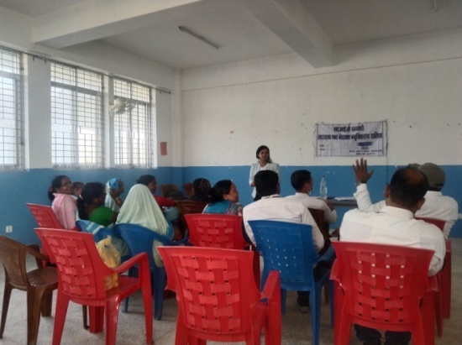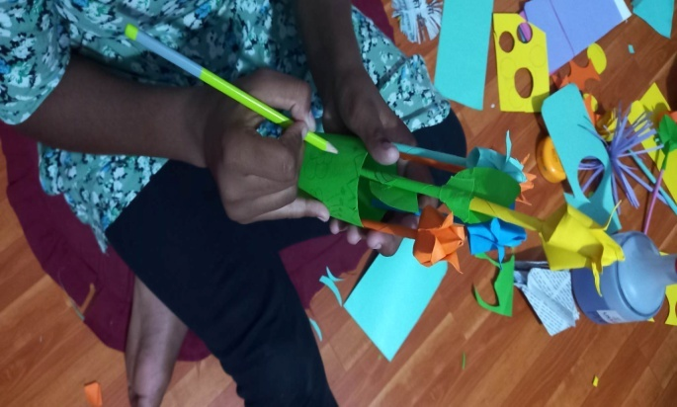
nfG5gf tyf e]befjGo"lgs/0f tflnd gjnk/f;L
nlIftju{nfO sfuhaf6 km'nagfpgl;sfOb} .
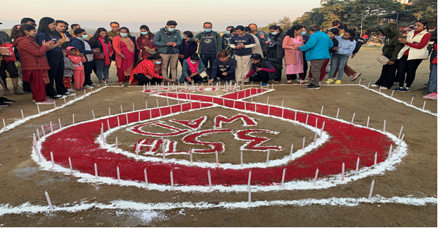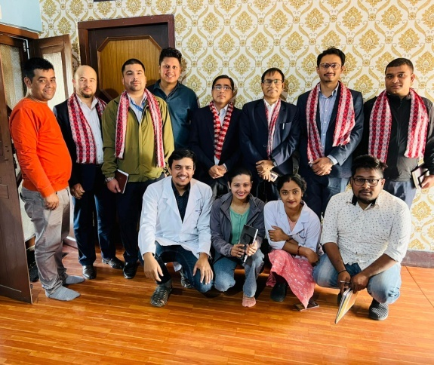
jfudtL k|b]z :jf:Yo dGqfnoaf6 lkmN8 cg'udg kZrft
#%cf+} +ljZj P8\; lba; dgfpb} lrtjgdf .

#=@= :yfgLo emf]n'Ë] k'n lgdf{0f sfo{qmddf k|fljlws ;]jf tyf ;fd'bflos kl/rfng M:yfgLo emf]n'Ë] k'n lgdf{0f sfo{qmd, lrtjg(Bridge Building at Local Level-Program, Chitwan)

s_ kl/ro
lrtjg lhNNffsf kxf8L uf=lj=;=x?df vf]nf tyf gbL cfjt hfjt ug{ c;'ljwf ePsf]n] emf]n'ª] k'nsf] dfu a9\b} cfO/x]sf] 5 . k/Dk/fut?kdf cfjt hfjtsf nflu ckgfOPsf ljleGg dfWodx? dfgljo Ifltsf lx;fan] ;+j]bglzn x'g] / jiff{tsf] ;dodf tL pkfox? k|efjsf/L gx'g] x'bf klg To:tf If]qdf o;sf] dfu a9\b} uPsf] xf] .
:yfgLo :jfoQ zf;g P}g, @)%% / lgodfnL, @)%^ sf] dd{ adf]lhd :yfgLo k"jf{wf/ gLlt @)^! sf] sfof{Gjog tyf emf]n'Ë] k'n /0fgLlt @)^@ adf]lhd emf]=k'= lgdf{0f tyf dd{t ;+ef/ sfo{df k|fljlws tyf ;fdflhs kl/rfngsf] nflu u}/;/sf/L If]qnfO{ kl/rfng u/fpg] ;/sf/sf] gLlt cg'?k v'Nnf k|ltZkwf{jf6 5gf}6 sfo{ eO{/x]sf] 5 . g]kfn ;/sf/ :yfgLo lasf; dGqfnon] cf=j )^^÷)^& b]lv emf]n'Ë] k'n If]qut sfo{s|dsf] ;+rfng (Trail Bridge Sector Wide Approach (TB SWAp) lgb]{lzsf–@)^^ cg';f/ ug]{ lg0f{o u/]sf] 5 . lrtjg lhNnf cGt/ut ;~rflnt 5f]6f] tl/sf -!@) dL ;Ddsf] nDjfO{_emf]n'Ë] k'n sfo{s|ddf ;fdflhs tyf k|fljlws ;xhLs/0fsf] nflu u}=;=;sf] e'ldsfdf ;xof]uL ;+:yfsf] ?kdf ;xefuL ;+:yfn] lg/Gt/ sfo{ub}{ cfPsf] 5 .
lrtjg lhNnf ljsf; ;ldlt, lhNnf ;dGjo ;ldlt tyf lhNnf k"jf{wf/ sfof{no lrtjg / ufpF tyf gu/kflnsf x?df ePsf] sfo{ k|Tofof]hg ;+emf}tfsf cfwf/df lgDgcg';f/ emf]n'Ë] k'n lgdf{0f ;DkGg eO{ ;s]sf 5g\ .

v_ emf]n'Ë] k'nx?sf] sfof{b]z k|fKt eP adf]lhd ;DkGg ePsf k'nx? ;d'bfodf x:tfGt/0f Pj+ cGo lgdf{0f k|lqmofsf] sfo{ rln/x]sf] 5 .

!=cf=j )&*.&( df ufp+÷gu/kflnsfaf6 sfof{b]z k|fKteO{ )&(.*) df ;DkGg emf]n'Ë]k'n
qm=; | emf]n'Ë] k'nx?sf] gfd | g=kf÷uf=kf | ;DkGg ldlt | k'nsf] k|sf/ | k'nsf] nDjfO{ -dL6/df_
! | tfNtLvf]nf | O=sfdgf–^ | )&(.)!.@( | D | 88
@ | jfª\Uofª emf]=k'n | O=sfdgf–! | )*).)#.)% | D | 75
# | /;f}nLl;¢L | /fKtL–( | )&(.)#.#) | N | 65
$ | dftf{nvf]nf | /fKtL –!! | )&(.)!.@( | D | 67
% | 3f]/afË emf]=k'n | sflnsf –( | )&(.)#.@# | N | 120
@=cf=j )&*.&( sf sfof{b]z k|fKt eO{ )*).*! df s|dfut /x]sf emf]n'Ë]k'n
qm=; | emf]n'Ë] k'nx?sf] gfd | g=kf÷uf=kf | ;DkGg ldlt | k'nsf] k|sf/ | k'nsf] nDjfO{ -dL6/df_
! | yfk|fËltkfË emf]=k' | O=sfdgf–! | )*).)^.#) | D | 72
@ | jfs|fËkvf{n emf]=k' | /fKtL –!@ | )*).)(.#) | D | 63
# | a8x/] emf]=k'n | sflnsf –* | )*).)^.#) | D | 59
$ | b}|fkltgu/ emf]=k' | df8L–)! | )*).)^.#) | N | 120
% | jfË;L/fª emf]=k' | /fKtL–!) | )*).)(.#) | N | 114
^ | dft{n-v_ emf]=k' | /fKtL –!! | )*).)^.#) | D | 73
& | u}8f3f/L emf]=k' | sflnsf –( | )*).)(.#) | N | 120
* | b]ph/ emf]=k' | sflnsf–!) | )*).)(.#) | D | 110
( | ;ldnwfk emf]=k' | O=sfdgf–& | )*).)(.#) | N | 102

#=cf=j )*)÷)*! sf nflu gofF ;e]{ug]{ nIo /flvPsf emf]=k' ljj/0f
qm=; | emf]n'Ë] k'nx?sf] gfd | g=kf÷uf=kf | s}lkmot
! | 6fS;Lvf]nf emf]=k'n | sflnsf –!)
@ | k}df/fª emf]= k'= | sflnsf –!)
# | rlt{w'd emf]=k'n | O=sfdgf–@
$ | 3lt{vf]nf emf]=k'n | O=sfdgf–@
% | nfnk;f{3f6 emf]=k'n | /Tggu/–(

u_ k'n lgdf{0f ;DjGwL s]lx tl:j/,

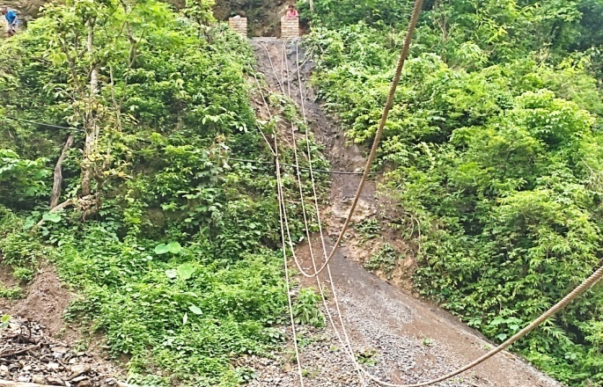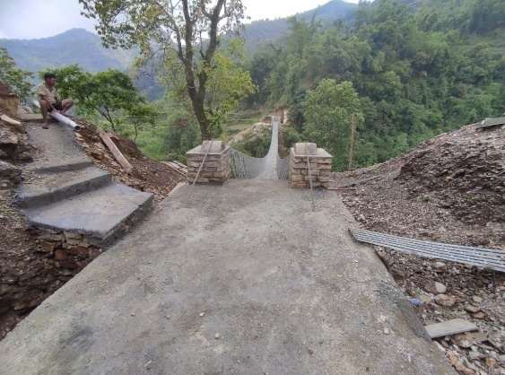
sflnsf gkf–*j8x/] vf]nfdf emf]=k'nsf] nÝf tfGb}sf] OR5fsfdgf ufkf ^ aªUofªsf] tof/L k’'n -D-Type)
cj:yf -D-Type)

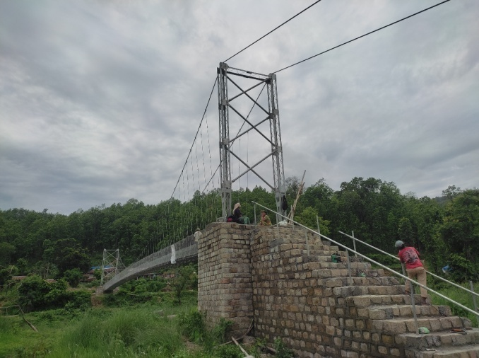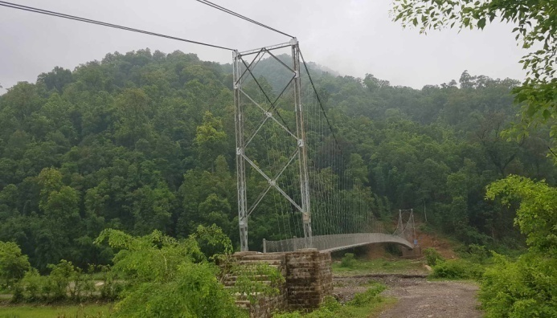
/fKtL gkf–!@,/;f}nLl;l4 vf]nfdf ;DkGg (N-Type)tof/L k'n . sflnsf gkf–(,3f]/jfª vf]nfdf ;DkGg (N-Type)tof/L k'n .

#=$= s[lif cg';Gwfg kl/of]hgf
pNn]lvt kl/of]hgf s[lif cg';Gwfgdf s]lGb|t /x]sf] 5 .;f] kl/ofhgfsf] cWooglaifo“Drivers of Safer Food Production and Consumption in Nepal: Understanding the Adoption of Food Safety Practices and Consumer Consciousness in Fresh Produce”/x]sf] 5 .kl/of]hgfsf] bft[lgsfo cd]l/sf l:yt Purdue/Cornell laZjlaWofnodf cjl:yt USAID 4f/f cfly{s ;xof]u u/]sf] km"8 ;]lkm\6L Ogf]e];g Nofj /x]sf] 5 .pQm kl/of]hgf ;+o'Qm ?kdf ;xefuL ,s[lifaglaZjlaWofno /fdk'/,lrtjg / cd]l/sfsf] Tenesse State University sf] ;xefuLtfdf ;Grfng ul/Psf] 5 .
- kl/of]hgfsf] gfd M s[lif cg';Gwfg kl/of]hgf (FASECC)
- sfo{If]q Mlrtjg, dsjfgk'/, ?kGb]xL, sf7df08f}, nnltk'/ / sf:sL
- kl/of]hgfcjlw M@ aif{ -! dfr{ @)@@ b]lv @* km]a|'c/L @)@$ ;Dd_
- nlIft ;d'bfo M vfWofGg pTkfbs / pkef]Qmf
- nfeflGjt ;+Vof M ^)) 3/w'/L
- l:js[t ah]6 ?=&),*),#*%.@)
- bft[lgsfo M Food safety Innovation Lab, USA

pknlAw M
- ^ hgf ;e]{Ifs 5gf}6 ul/ tYofÍ ;+sngsf] nflu cfwf/e"t tflnd pknAw eof] .
- kl/of]hgfdf ePsf] ;+emf}tf adf]lhd dxfgu/kflnsf / pkdxfgu/kflnsfdf ;Dks{ ;dGjo ul/ jf8{ / 3/w'/L 5gf}6 u/Lof] .
- 3/w'/Ldf uO{ ;e]{ tYofÍ ;+sngsf nflu k|fKt lglb{i6 9fFrf cg';f/sf] kmf/d c+u|]hL efiffnfO{ g]kfnLdf cg'jfbsf] sfo{ ;DkGg ul/of] .
- 5gf}6df k/]sf ^)$ 3/w'/Ldf uO{ lglb{i6 9fFrfsf] kmf/ddf Qualtrics App dfkm{t tYofÍ ;+sngsf] sfo{;DkGg ul/of] .
- s[lif ag laZj laWofno /fdk'/,lrtjgsf] ;dGjodf bft[lgsfosf] cg'udg sfo{df ;xhLs/0f .
- ;+emf}tf adf]lhdsf &) k|ltzt sfo{ ;DkGg eof] .
- ;dfh sNof0f kl/ifb 4f/f sfo{s|d l:js[t .

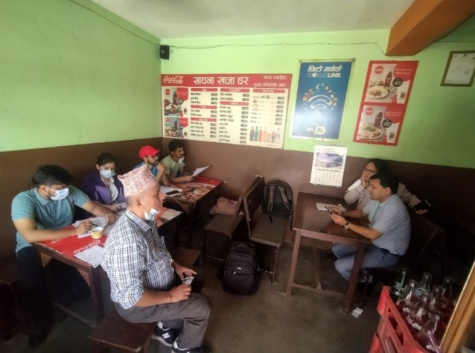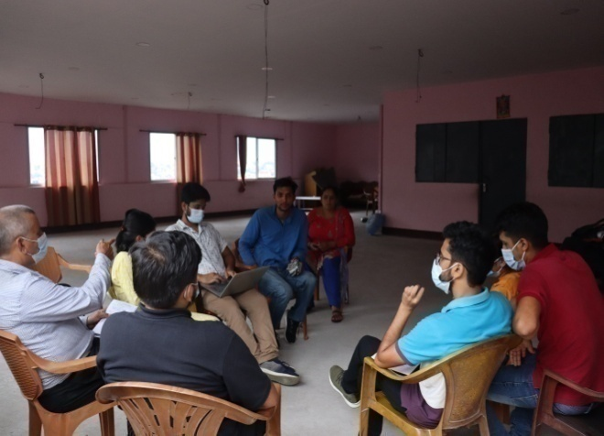
s[lif ag lj1fg laZjlawofnoaf6 cg'udg Tffhf t/sf/L pkef]Qmf ;j]{If0f 6f]lnsf] ;ldIff a}7s

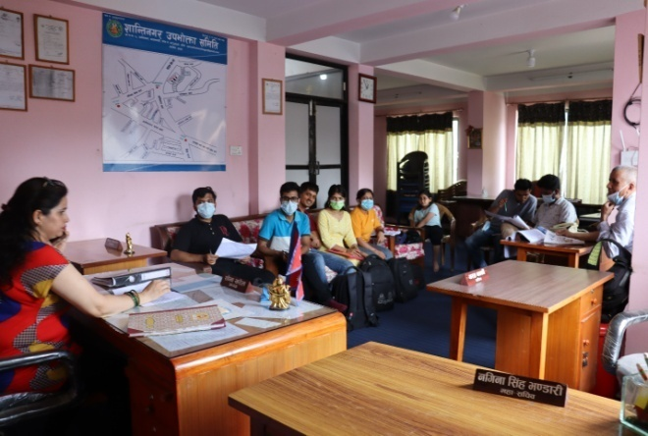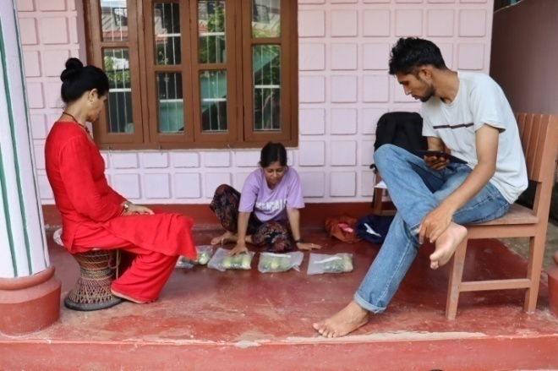

3/w'/L klxrfgsfnflu 6f]n;'wf/ ;ldlt ;+u ;dGjo a}7s WTP k|fKtL ug{] sfsf]sf] v]n v]nfpFb} k|fljlws ;e]{Ifs

$=cWoog tyf cg'zGwfgfTds sfo{s|d M

%= k|sfzgx? (Publications)

s_ jflif{s Sofn]08/ -uf]hL kfqf] _
;+:yfn] sfof{Gjog ub]{ cfPsf sfo{s|dx?nfO{ Jojl:yt / of]hgfj4 lsl;daf6 ;~rfng ug{sf nflu @)*) sf] jflif{s Sofn]08/ (Year Planner) k|sfzg ul/ ;+:yfsf ;fem]bf/ tyf ;/f]sf/jfnf lgsfox? P+j z'elrGtsx?nfO{ ljt/0f ul/Psf] 5 . o; uf]hL kfqf]n] ;+:yfsf] ;+lIfKt lrgf/L, sfo{s|dx?sf] ljj/0f, dxTjk'0f{ ;Dks{ gDa/ nufot @)*! ;fnsf] Sofn]08/nfO{ ;d]6]sf] 5 . o;sf] k|sfzgaf6 sfo{s|d ;~rfngdf ;xhtf / ;Dks{, ;dGjo / ;+:yfut k|rf/ k|;f/df ;xof]u k'u]sf] 5 .

v=_ ;xefuL ;dfrf/ k|sfzg M
;xefuL ;+:yfn] @)^$ ;fnaf6 ;xefuL ;dfrf/sf] k|sfzg sfo{ k|f/De u/L )&# ;fn ;Dd lg/Gt/ ?kdf k|sfzg e}/x]sf] lyof] . ;+:yfaf6 laleGg kl/of]hgfsf] dfWodaf6 sfo{If]qdf ;~rflnt ultljlwx? nfO{ ;dfa]z u/L afl{if{s tyf cw{jfli{fs ?kdf k|sfzg ul/b} cfPsf] lyof] . ;+:yfdf hgzlQmsf] km]/abn ,bft[lgsfo ;+usf] ;xsfo{df Go"lgs/0f x'g'sf] ;fy} sf]le8–!(sf] c;/n] sl/j % aif{ ;Dd k|sf;gsf] sfo{ :yug x'g uof] . ;dfrf/ :yugn] kf7sau{df kg{ uPsf] c;'lawf k|lt Ifdf k|fyL{ 5f}+ . ;xefuL ;dfrf/ k|sfzgaf6 ;/f]sf/ /fVg] ;+3 ;+:yf / s[ifs;d'bfonfO{ lasf;;+u ;DalGwt ultljlwx?nfO{ a'em\g a'emfpg s]xL xb;Dd 6]jf k'/\ofPsf] dx;'; ul/Psf]n] k'Mg k|sfzg u/]sf 5f}+ .

^= :jLs[t sfo{qmd tyf ah]6 cg';f/ vr{ k|ult

;+:yfsf] aflif{s n]vfkl/If0f k|ltj]bgdf jh]6cg';f/ vr{ ljj/0f la:t[t?kdf /x]sf] / ;f] k|ltj]bg ;+:yfsf]

website: www.sahavagi.org.np k9\g tyf 8fpgnf]8 ug{ ;lsG5 . ljQLo ;f/f+z, jff;nft tyf cfo

Joo ljj/0f jflif{s n]vf k/LIf0f k|ltj]bg cf=j= @)&(÷)*) jf6 k|fKt ug'{x'g cg'/f]w 5 .

&= cf= j= @)&(÷)*) df ;~rflnt sfo{s||d
qm ; | sfo{qmd | ;xof]uL ;+:yf | s}lkmot
! | Plss[t kl/jf/ lgof]hg, Pr=cfO{=le=/f]syfd, pkrf/ / :ofxf/ sfo{s|d lrtjg / gjnk/f;L | USAID/FHI-36o -Olks g]kfn kl/of]hgf_ | lg/Gt/
@ | :yflgo ´f]n'Ë] k'n lgdf{0f sfo{qmd, lrtjg | :yfgLo kflnsfx? lrtjg l6=lj=P;=o'=, x]Ne]6f; | lg/Gt/
# | s[lif cg';Gwfg kl/of]hgf | Food safety Innovation Lab, USA | @)*) r}q ;Dd dfq .

*= cf= j= @)*)÷)*! sf] k|:tfljt sfo{s|d tyf ah]6
cfufdL aif{sf nflu o; aif{ ;+rflnt sfo{s|dx?sf] lg/Gt/tf :j?k lgDgfg';f/sf sfo{s|d /x]sf 5g\ .
Income and Expenditure FY 2080/081
Description | Total Income | Total Expenditure | Net Income | Remarks
Income from FSIL | 9,23,694.00 | 9,23,694.00 | 0
Income from EpiC | 165,00,000.00 | 165,00,000.00 | 0
New Project (TCF-  The Charitable Foundation ) | 5,000,000.00 | 5,000,000.00 | 0 | -
New project (SSU ) | 2500000.00 | 2500000.00 | 0
Income of Central Office (Overhead ,Interest,Membership Fee,Land Rent & BBLL project ) | 3,008,870.00 | 2,671,793.00 | 337,077.00
Net Operational Surplus | 27,932,564.00 | 27,595,487.00 | 337,077.00

Tentative Budget Summary (FY 080/081)
Project Budget ( Program Cost ) | 24,923,694.00 | 90
Central Office Budget (opretional Cost ) | 2,671,793.00 | 10
Total Budget | 27,932,564.00 | 100%

(= ;+u7gfTds 9fFrf -;+:yf ;+/rgf_

साधारण सभा

संचालक समिति

अध्यक्ष

केन्द्रीय कार्यालय

स्थानीय झोलुंगे पुल निर्माण कार्यक्रम
१. जनशक्ति व्यवस्थापन विभाग

२. अनुगमन तथा मुल्यांकन विभाग

३. अध्ययन अनुसन्धान विभाग

४. प्रशिक्षण विभाग
%. अनुसन्धान तथा मुल्यांकन
समिति

कार्यालय प्रमुख

फासेक परियोजना

शाखा कार्यालय
१. भरतपुर १० स्याउलीबजार
२. बर्दघाट

एच. आइ. भी. एड्स रोकथाम हेरचाह सहयोग तथा उपचार कार्यक्रम

